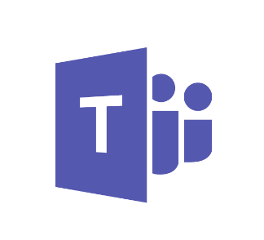

Practical Guidance for Microsoft Teams

© 2017 Microsoft Corporation. All rights reserved. This document is provided "as-is." Information and views expressed in this document, including URL and other Internet Web site references, may change without notice.

This document does not provide you with any legal rights to any intellectual property in any Microsoft product. Microsoft Teams customers and partners may copy, use and share these materials for planning, deployment and operation of Microsoft Teams.

Table of Contents

Introduction 3

Prerequisites 3

Intended Audience 3

Version History 3

Objectives 3

Plan 4

Overview of Microsoft Teams 4

Architecture of Microsoft Teams 5

Microsoft Teams Current Environment Checklist 5

Getting Started with Microsoft Teams 6

Clients for Microsoft Teams 11

Office 365 Licensing for Microsoft Teams 12

Managing Microsoft Teams 13

Roles and Permissions 15

Network Planning for Microsoft Teams 16

Compliance & Security 18

Skype for Business Interoperability 20

End User Awareness and Adoption 23

Deliver 28

Prerequisites to Microsoft Teams Deployment 28

Microsoft Teams Configuration 28

Groups, Roles and Permissions 31

Microsoft Teams Client Deployment, Updates and Security 34

Extensibility 36

Security and Compliance 47

Operate 48

Monitoring Usage and Quality 48

Security and Compliance 48

Troubleshooting 50

Appendix 53

Architecture of Microsoft Teams 53

Identity and Authentication Methods 53

Exchange Deep Dive 55

Office 365 Groups 57

SharePoint Online and OneDrive for Business 58

Microsoft Teams Feature-level Enablement 59

# Introduction

Microsoft Teams is the digital translation of an open-space, office environment that fosters easy connection and conversations to help people collaborate and build relationships.

We leveraged a framework to create an initial set of practical guidance to help you Plan, Deliver and Operate Microsoft Teams. We documented the key information that we think you will find useful during your project including the accompanying workshop. We will continue to iterate this guidance and release the most updated information as it becomes available.

Be sure to check [www.SuccessWithTeams.com](http://www.SuccessWithTeams.com) for the latest practical guidance.

## Prerequisites

This document assumes that you have completed the Microsoft Teams readiness sessions listed below, and have a baseline understanding of this tool:

* **Required:** Introduction: <https://aka.ms/microsoft-teams-introduction>
* **Highly Recommended:** Deployment & Operation: <https://aka.ms/microsoft-teams-deployment>

If you have not completed the trainings above, please do so before continuing with the rest of the document.

## Intended Audience

This document is for the team who is deploying Microsoft Teams in your organization. We suggest that the initial team is comprised of the following roles:

* Project Sponsor
* Business Analyst
* Project Manager
* Collaboration IT Pro
* Networking IT Pro
* Adoption Lead
* Support Lead

## Version History

*Table 1 – Summary of Changes*

|  |  |  |
| --- | --- | --- |
| Version | Changes | Date |
| 1.0 | Initial Release | 14-Mar-2017 |
|  |  |  |

## Objectives

We created this document to meet the following objectives:

* Drive your success by providing practical guidance to your team as you engage to deliver Microsoft Teams to your organization.
* Encourage your team to think through the three main project phases: Plan, Deliver and Operate.
* Provide a set of key decisions and follow on actions that you can use to drive your project.
* Share examples of how to go about engaging with the user community to set up Microsoft Teams.
* Collect relevant background material in the Appendix of this document that will underpin your understanding of the architecture of Microsoft Teams.
* Once you have read this document you will be ready to engage on a successful delivery of Microsoft Teams.

# Plan

## Overview of Microsoft Teams

Microsoft Teams brings together the full breadth and depth of Office 365, to provide a true chat-based hub for teamwork and give customers the opportunity to create a more open, fluid, and digital environment.  Microsoft Teams is built on existing Microsoft technologies woven together by Office 365 Groups.

Out of the box, Microsoft Teams leverages identities stored in Azure Active Directory (Azure AD) and integrates with the other services within Office 365, to creates a SharePoint online site and an Exchange Online group mailbox for each team created.

Microsoft Teams persistent chat capability is provided by a chat service that interacts with the Office 365 substrate, surfacing many of the built-in Office 365 capabilities, such as archiving and eDiscovery to the data being exchanged in Microsoft Teams.

Microsoft Teams also provides a calling and meetings experience that is built on the next generation cloud-based infrastructure that is also used by Skype and Skype for Business. These technology investments include Azure-based cloud services for media processing and signaling, H.264 video codec, SILK and Opus audio codec, network resiliency, telemetry, and quality diagnostics.

To extend Microsoft Teams capabilities, Connectors, Tabs, and Bots are available as extensibility options to bring external information, contents, and intelligent bots interactions to Microsoft Teams.

### Microsoft Teams and Office 365

Office 365 applications are built on the Office 365 Groups service, enabling end users to choose the application that works best for their specific collaboration needs. The most common usage scenarios for how customers are leveraging these tools today are listed below.

**Microsoft Teams:**

* Leveraged by users and teams who are looking to collaborate in real-time with the same group of people.
* Helps teams looking to iterate quickly on a project while sharing files and collaborating on shared deliverables.
* Allows Users looking to connect a wide range of tools into their workspace (such as Planner, Power BI, GitHub, etc.).

**Outlook:**

* Leveraged by users looking to communicate in more formal, structured manner.
* Provides specific business processes that require email usage to transmit documents and information inside and outside corporate boundaries.
* Communicates and connects with users who are outside of immediate workgroups or organizations.
* Has low-frequency interactions that do not require immediate action.

**Yammer:**

* Leveraged to help connect users across the organization share best practices or participate in a community of practice.
* Connects one to many and crowdsource ideas and topics, through its enterprise social network.
* Helps customers looking to foster two-way conversations between leadership and staff.
* Supports communities for company services.

**Skype for Business:**

* Allows organizations with real-time communication and collaboration both internally and externally with customers/partners.
* Provides meetings with audio, video and content with small or large teams (including Town Halls with up to 10,000 participants).
* Offers enterprise telephony functionality.

**SharePoint Online:**

* Creates company organizational intranet sites for news and resources.
* Implements business process automation on libraries and lists of information by integrating Flow, PowerApps and other automation tools.
* Deploys project information sites that are public to your entire organization.

## Architecture of Microsoft Teams

Microsoft Teams is built on existing Microsoft technologies woven together by Office 365 Groups. Powered by Microsoft’s cloud, organizations can expect excellent performance and reliability when leveraging Microsoft Teams as part of their collaboration story. For a more detailed look at what makes Microsoft Teams run, please see the *Architecture of Microsoft Teams*section.

**NOTE:** The Architecture of Microsoft Teams section of this guide in the Appendix is intended for technical audiences such as IT Pros and IT Admins.

## Microsoft Teams Current Environment Checklist

The only requirement for your organization to begin enhancing your organization’s collaboration experience is an Office 365 subscription that includes Microsoft Teams. This means, whether you are new to Office 365, or a long-time Office 365 subscriber, your organization can get started with Microsoft Teams right away.

The transition to the cloud will vary from organization to organization, and current state may have an impact on how Microsoft Teams will function. To determine if your current state will impact Microsoft Teams functionality, please review the Environment Checklist below.

*Table 2 - Teams Environment Checklist*

|  |  |
| --- | --- |
| Question | Answer |
| Has your organization already deployed other Office 365 workloads? (Exchange Online, SharePoint Online, Skype for Business Online, etc.) | If no, please see [Getting Started with Office 365 for business](https://support.office.com/en-us/article/Get-started-with-Office-365-for-Business-d6466f0d-5d13-464a-adcb-00906ae87029) on getting started with Office 365. |
| Has your organization configured a verified domain for Office 365?  If yes, please include the verified domain(s) in your answer. | If no, please see [Verify your Office 365 domain](https://support.office.com/en-us/article/Verify-your-Office-365-domain-to-prove-ownership-nonprofit-or-education-status-or-to-activate-Yammer-87d1844e-aa47-4dc0-a61b-1b773fd4e590) on adding a verified domain to Office 365. |
| Does your organization synchronize identities to Azure Active Directory? | If no, please see Identity and Authentication Methods in the Appendix for additional information. |
| How is Exchange deployed in your organization?  Exchange Online  Exchange Hybrid  Exchange On-premises  Not deployed | If you selected anything other than Exchange Online, please see Exchange Deep Dive in the Appendix for additional information. |
| How is SharePoint deployed in your organization?  SharePoint Online  SharePoint Hybrid  SharePoint On-premises  Not deployed | If you selected anything other than SharePoint Online, please see SharePoint Online and OneDrive for Business in the Appendix for additional information. |
| How is Skype for Business deployed in your organization?  Skype for Business Online  Skype for Business Hybrid  Skype for Business On-premises  Not deployed | If you have Skype for Business deployed currently for your organization, please see Skype for Business Interoperability for additional information. |
| What Office 365 subscriptions does your organization currently use? | Please see the Office 365 Licensing for Microsoft Teams |

## 

## Getting Started with Microsoft Teams

Let’s get started by thinking about how Microsoft Teams allows individual teams to self-organize:

* Teams are a collection of people, content, and tools surrounding different projects and jobs within an organization.
  + Teams can be created to be private to only invited users.
  + Teams can also be created to be public and open to anyone within the organization to join up to 999 members.
* Channels are dedicated sections within a team to keep conversations organized by specific topics, projects, disciplines—whatever works for your team!
  + Team channels are places where everyone on the team can have open conversations. Private chats are only visible to those people in the chat.
  + Channels can be extended with Tabs, Connectors, and Bots.

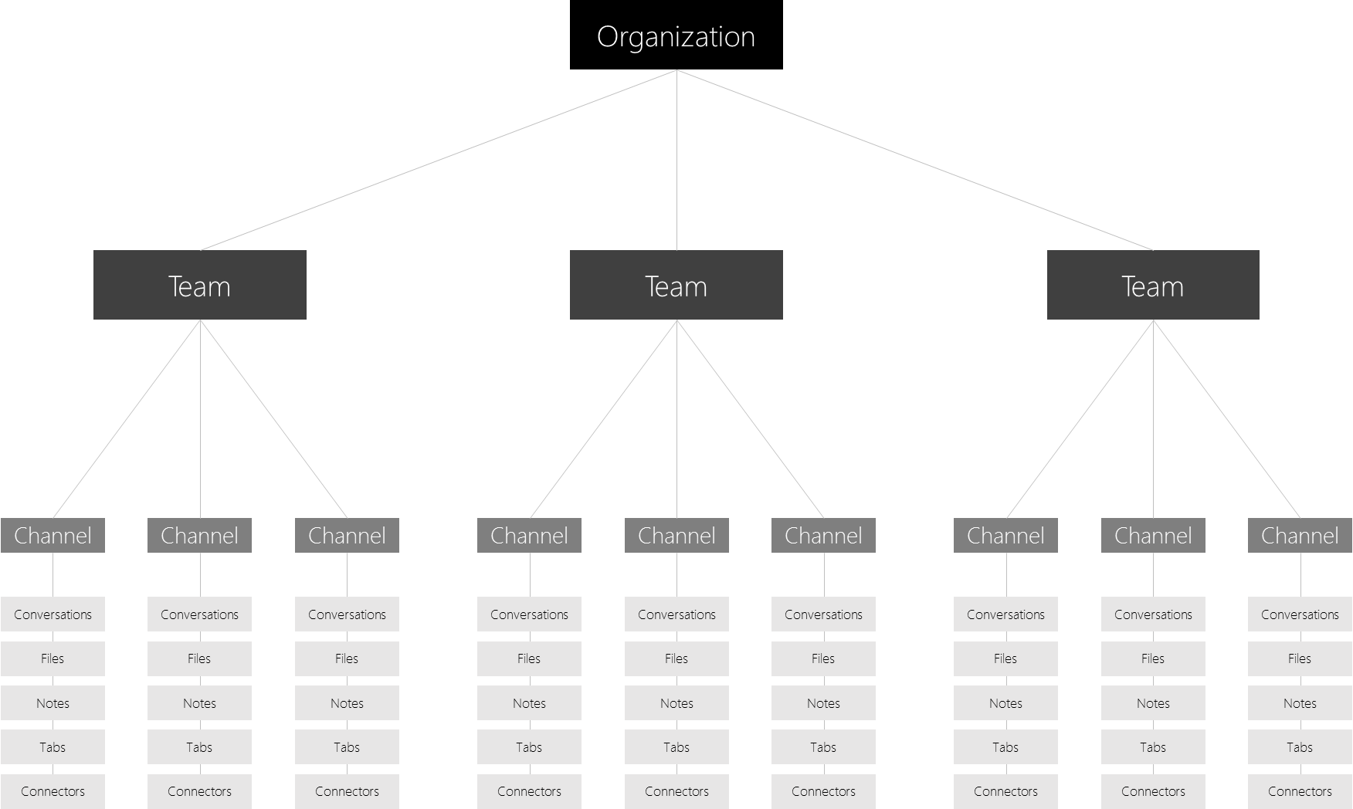

Figure 1: Microsoft Teams channel structure

One key early planning activity in helping your users engage with Microsoft Teams is helping people think about how Microsoft Teams can help enhance collaboration in their day to day lives.

### Sample Teams & Channel Set up

Below are a few functional examples of how different types of users may approach setting up their teams, channels and tabs/connectors/bots – this may be useful to help kick off a conversation about Microsoft Teams with your user community. As you think through how you will implement Microsoft Teams in your organization, remember that you can provide guidance on how to structure their teams, however users have control of how they can self-organize. These are just examples to help get teams to start thinking through the possibilities.

Microsoft Teams is great at breaking down organizational silos and promoting cross-functional teams, so encourage your users to think about this as functional teams and not organizational silos.

Table - Team Type & Channel Set Up

|  |  |  |
| --- | --- | --- |
| Type of team | Potential channels | Potential tabs/  connectors/bots |
| Sales | Product Updates  Marketing  Existing Customers  Market Updates  Leads | PowerBI  Trello  CRM  Summarize Bot |
| Marketing | Product Updates  Campaign #1  Strategy  Compete | YouTube  Microsoft Stream  Twitter  MailChimp |
| Technical Operations | Incident Management  Release Management  Known Issues  Product Support | Team Services  Jira  AzureBot |
| Product Team A | Strategy  Marketing  Sales  Operations  Insights  Service & Support |  |
| Engineering | Feature Planning  Ship Schedule  Data & Telemetry  Feedback and Onboarding | Team Services  Jira  GitHub |
| Finance | Current Fiscal  FY Planning  Forecasting | Power BI  Google Analytics |
| Logistics | Warehouse Operations  Vehicle Maintenance  Driver Rosters | Weather Service  Travel / Road Disruptions  Planner  Tubot  UPS Bot |
| HR | Talent Management  Recruiting  Performance Review Planning  Morale | HR tools  External Job Posting Sites  Growbot |
| Cross-organizational  Virtual Team | Strategy  Workforce Development  Compete & Research |  |

### Organizing Teams

Before creating a team, it is a good practice to begin by thinking of a goal, a project or even a work item that you are working on and think about the collection of people/groups in the organization who can help deliver that collaboratively, you would then create the team and add these people/groups to get going (be selective in adding people and groups to help achieve that goal). It is a good idea to set up more than one Owner for each team (see *Roles and Permissions* later in this document).

You may start with a small number of team members to brainstorm as you move forward, and then add new people/groups as you go. The great thing with Microsoft Teams, is that when you add new people/groups, they can quickly get up to speed on what has already been discussed as the conversations and files are available to users regardless of when they join. Try to avoid creating different teams that have the same set of members, as this approach may not provide the focus that you are looking for to deliver the project or goal. Outlook is a great tool for sharing those type of group wide communications.

Once you have created your team, it’s a good idea to start to think about the different areas of conversations that you want to have to drive towards your goal and create initial channels so that people know where to contribute and to find existing conversations. Be descriptive in the names of the channels to make it easier to understand what the conversation in the channel is there to achieve. You can add new Tabs to channels to add tools like OneNote, PowerBI or links to web pages and other content to make it easy for people to find content and share their thoughts.

The General channel is created for you when you create the team. You can use this to share an overview of what the team wants to achieve and other high-level information that a new team member would find useful. Currently, you cannot remove or unfavorite the General channel. The General channel is a great place to pin a project charter or welcome deck to your project. This ensures that as new people onboard your team, they have a single source of truth for your objectives. When naming channels remember that the channels will be ordered alphabetically after the General channel.

### Microsoft Teams Journey

A typical Microsoft Teams journey may take the following form:

1. Technical and legal assessment in the early stages to identify and define what controls are required to implement Microsoft Teams in your organization.
2. Undertake a Network assessment and prepare for the rollout. At this point you can start to create the adoption and change management strategy and key user stories that will drive user engagement during and after the rollout.
3. Test these change management and adoption strategies out with an IT Pilot.
4. Refine and run a business pilot in one or two business units leveraging these strategies.
5. Refine and leverage the strategy and learnings for a wider rollout.

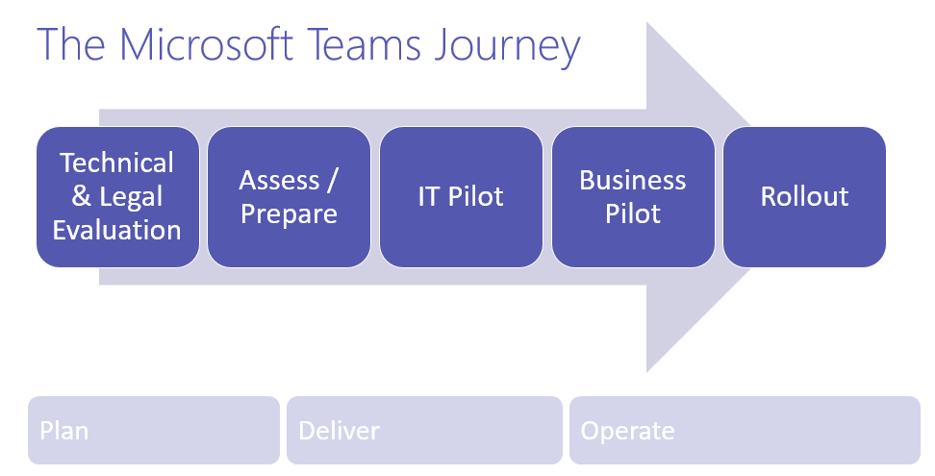

Figure 2 - Teams Reference Sequence

During the journey, one of the first uses of Microsoft Teams in your environment is the IT pilot. Consider leveraging this pilot to help your team engage to plan, deliver, and operate Microsoft Teams and outreach to the business users.

Here’s an example of how you could set up a team / channel structure to help drive towards your goal of delighting your end users through the delivery of Microsoft Teams. To get your business units thinking of how to set up their own teams and channels, you could share how you set up your first team / channels to help them and perhaps encourage users to create a simple table like the one below to drive the conversation.

Table - First team channel & setup example

|  |  |  |
| --- | --- | --- |
| Team Name | Channels | Tabs |
| Get Teams Deployed  Members:  Project Sponsor  Business Analyst  Project Manager  Collaboration IT Pro  Networking IT Pro  Adoption Lead  Support Lead  Owners:  Project Manager  Collaboration IT Pro | Planning and Readiness  Adoption  Rollout  Support  Insights | Link practical guidance for Microsoft Teams web page (www.SuccessWithTeams.com) |

This setup would look like this in Microsoft Teams:

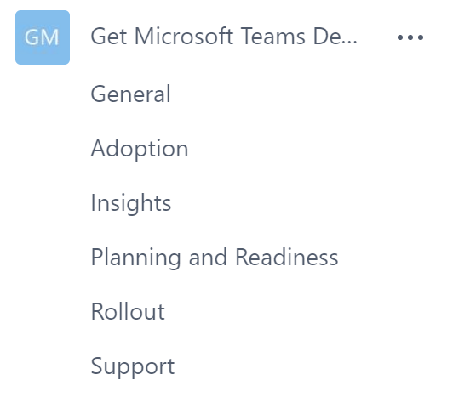

Figure 3: Sample Microsoft Teams setup

|  |  |  |
| --- | --- | --- |
|  | **Decision Point** | *What initial teams and channels do you want to create for your IT pilot?*  *What team members do you want to add to each Team and Channel?* |
|  | **Next Steps** | *Document these in the table below. Add rows as needed.* |

Table - Teams IT Setup

|  |  |  |  |  |  |
| --- | --- | --- | --- | --- | --- |
| Team Name | Description | Owner(s) | Member(s) | Channel(s) | Privacy |
|  |  |  |  |  |  |
|  |  |  |  |  |  |
|  |  |  |  |  |  |

## Clients for Microsoft Teams

Microsoft Teams has clients available for web, desktop (Windows and Mac), and mobile (Android, iOS, and Windows Phone). These clients all require an active internet connection and do not support an offline mode.

### Web Client

The web client (<https://teams.microsoft.com>) is a full, functional client that can be used from a variety of browsers. At this point, the web client does not support real-time communications (i.e. joining meetings and having one to one calls). The browser must also be configured to allow third party cookies.

Supported browsers (and versions) for Microsoft Teams are the following:

* **Edge**: 12+
* **Internet Explorer:** 11+
* **Chrome**: 51.0+
* **Firefox**: 47.0+

**Note**: Safari is not yet supported, but is coming soon.

For more information please review the [Microsoft Teams FAQ](https://support.office.com/en-US/article/Frequently-asked-questions-about-Microsoft-Teams-–-Admin-Help-05cbe533-2181-4e95-a4b0-52cd7695fafc).

### Desktop Clients

Microsoft Teams desktop client is a standalone application and currently not part of Office Pro Plus. Microsoft Teams is available for both Windows (7+), both 32-bit and 64-bit versions, and MacOS (10.10+).

The desktop clients provide real-time communications support (audio, video, and content sharing) for team meetings, group calling and private one-on-one calls.

### Mobile Clients

The mobile apps for Microsoft Teams are available for Android, iOS, and Windows Phone, and they are geared at users participating in the chat-based conversations while on the go, and currently allows users to have peer to peer audio call.

Supported mobile platforms for Microsoft Teams mobile apps are the following:

* **Android**: 4.4 or later
* **iOS**: 10.0 or later
* **Windows Phone**: Windows 10 Mobile

### Client Deployment and Updates

The Web client will perform browser version detection upon connecting to [https://teams.microsoft.com](https://teams.microsoft.com/) and if unsupported version of browser is detected, it will block access to the Web interface and recommend that user download the desktop client or mobile app.

Desktop clients can be downloaded and installed by end users directly from <https://teams.microsoft.com/downloads> if they have the appropriate local permissions (admin rights are not required to install the Teams client on a PC). Admins can also download the installer and distribute it through client distribution tools such as System Center Configuration Manager (Windows) or Casper Suite (MacOS).

Desktop clients are automatically updated, therefore ongoing maintenance of the desktop clients from IT perspective will be minimal.

Mobile apps are distributed and updated through the respective mobile platform’s app store only, and are not available to be distributed through MDM (mobile device management) solutions or side-loaded.

|  |  |  |
| --- | --- | --- |
|  | **Decision Point** | *Are there any restrictions preventing users from installing the appropriate Microsoft Teams client on their devices?* |
|  | **Next Steps** | *If your organization restricts software installation, make sure that process is compatible with Microsoft Teams. Note: Admin rights are not required for PC client installation but are required for installation on a Mac.* |

## Office 365 Licensing for Microsoft Teams

The following Office 365 subscriptions will enable users for Microsoft Teams:

* Office 365 Business Essentials
* Office 365 Business Premium
* Office 365 Enterprise E1
* Office 365 Enterprise E3
* Office 365 Enterprise E4— existing subscriptions only (retired plan)
* Office 365 Enterprise E5

**Note**: Microsoft Teams is also available for non-profit organizations. Government and educational licensing are not currently supported, but are being investigated for future support.

In terms of Microsoft Teams **core** functionalities, there are no differences between the different Office 365 subscriptions, the availability of the compliance capabilities does rely on the correct subscription level. (See Information Protection Licensing for more information.)

All supported subscription plans are eligible for access to Microsoft Teams’ Web client, desktop clients, and mobile apps.

### Microsoft Teams License

By default, Microsoft Teams license is enabled for all users assigned with the eligible Office 365 subscriptions.

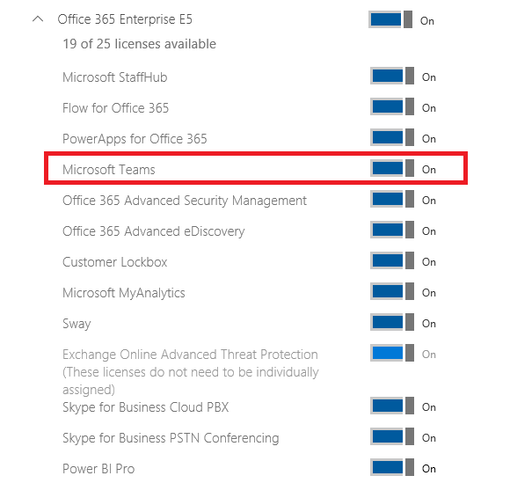

Figure 4: Individual User License Assignment

Microsoft Teams can be enabled or disabled for the entire organization and is enabled by default. If an organization intends to operate a pilot of Microsoft Teams with a selective set of users, while actively restricting access to Microsoft Teams for other users, then Microsoft Teams license must be disabled for all users that are not part of the pilot group.

## Managing Microsoft Teams

Microsoft Teams comes with management capabilities that support the requirements for a chat-centered workspace.

### Tenant-level Configuration

At the tenant-level, Microsoft Teams can be enabled or disabled for the entire organization via an on/off slider. By default, all tenants will have Microsoft Teams enabled.

For details on how to enable or disable Microsoft Teams at the tenant level, please see the Tenant-level Enablement section of this document.

**Note:** The tenant-level capability to control the on/off status of Microsoft Teams is temporary and will be removed in the future. At that time, access to Microsoft Teams will be controlled via user-level licensing only.

### User-level Configuration

At the user-level, access to Microsoft Teams can be enabled of disabled on a per user basis by assigning or removing the Microsoft Teams product license.

Currently, there are no policy options for turning Microsoft Teams, or a subset of Microsoft Teams features on or off at an individual user-level outside of licensing.

To restrict access to Microsoft Teams for a given user, the entitlement for the license assigned to that individual user needs to be modified to set Microsoft Teams to disabled. For details on how to enable or disable Microsoft Teams at the user level, please see the User-level Enablement section of this document.

**Note**: Microsoft recommends that Microsoft Teams is enabled for all users in a company so that teams can be formed organically for projects and other dynamic initiatives. Even if you are deciding to pilot, it may still be helpful to keep Microsoft Teams enabled for all users, but only target communications to the pilot group of users.

|  |  |  |
| --- | --- | --- |
|  | **Decision Point** | * *What is your organization’s plan for Microsoft Teams onboarding across the organization? (Pilot or Open)* |
|  | **Next Steps** | * *If onboarding via a closed Pilot, decide if you would like to do so via licensing, or targetted communication.* * *Depending on decision, take steps to make sure only Pilot users who are allowed to access Microsoft Teams (if needed)* * *Document the guidelines for which users who will (or will not) have access to Microsoft Teams below.* |

|  |  |
| --- | --- |
| How will you determine which users will get access to Microsoft teams? | <describe criteria here> |

### Features Enablement

Microsoft Teams has multiple settings that can be enabled or disabled at the tenant level. With Microsoft Teams enabled for the tenant, any user that is also enabled for Microsoft Teams will inherit the settings from the tenant level. For details on each of these features, please see the Feature-level Enablement section of the Appendix.

An Office 365 Administrator can choose to enable or disable multiple capabilities within Microsoft Teams.

|  |  |  |
| --- | --- | --- |
|  | **Decision Point** | *What settings for Microsoft Teams will your organization enable?* |
|  | **Next Steps** | *Document these decisions in the table below.* |

**Bolded** answers are the defaults

Table - Team settings & features

|  |  |  |
| --- | --- | --- |
| Admin Section | Admin Setting | Setting |
| Overall | Turn Microsoft Team on or off for your entire organization | **On**  Off |
| General | Show organization chart in personal profile | **On**  Off |
| General | Use Skype for Business for recipients who don’t have Teams | **On**  Off |
| Calls & Meetings | Allow scheduling for private meeting | **On**  Off |
| Calls & Meetings | Allow scheduling for channel meeting | **On**  Off |
| Calls & Meetings | Allow videos in meetings | **On**  Off |
| Calls & Meetings | Allow screen sharing in meetings | **On**  Off |
| Messaging | Allow private chat conversations | **On**  Off |
| Messaging | Enable Giphy so users can add gifs to conversations | **On**  Off |
| Messaging | Content Rating  Note: this can be modified and set higher for individual teams | Strict  Moderate  Allow all content |
| Messaging | Enable memes that users can edit and add to conversations | **On**  Off |
| Messaging | Enable stickers that users can edit and add to conversations | **On**  Off |
| Bots & Tabs | Allow bots and tabs in Microsoft Teams | **On**  Off |
| Bots & Tabs | Allow side loading of external bots and tabs | On  **Off** |
| Email Integration | Allow users to send emails to channels | **On**  Off |

## Roles and Permissions

Microsoft Teams does not have any custom RBAC roles in the O365 Administrator roles. Within Microsoft Teams there are two roles: Owner and Member.

Table - Teams Roles and Permissions

|  |  |  |
| --- | --- | --- |
|  | Team Owner | Team Member |
| Create team | ✓ | - |
| Leave team | ✓ | ✓ |
| Edit team name/description | ✓ | - |
| Delete team | ✓ | - |
| Add channel | ✓ | ✓* |
| Edit channel name/description | ✓ | ✓* |
| Delete channel | ✓ | ✓* |
| Add members | ✓** | - |
| Add tabs | ✓ | ✓* |
| Add connectors | ✓ | ✓* |
| Add bots | ✓ | ✓* |

* These items can be turned off by an owner at team level, in which case members would not have access to that.

**After adding a member to a team, an Owner can also promote a Member to Owner status. It is also possible for an Owner to demote their own status to a Member.

### Management of Roles

By default, a user that creates a new team is granted the Owner status. If a team is created from an existing Office 365 Group, permissions are inherited. For more details, please see the deployment section of Office 365 Groups.

A user with the Owner role in a Team can promote or demote any other Owner or Member between team roles.

### Assign Roles

Owners can make other members owners in the **View teams** option. A team can have up to 10 owners.

### Office 365 Groups

Any user who has the permissions to create an Office 365 Group and is enabled for Microsoft Teams can create a new team and they will be assigned owner permissions for that team. By default, all users with a mailbox in Exchange Online can create Office 365 Groups. To restrict permissions for the creation of Office 365 Groups and thus limit the creation of new Teams, please see the Groups section of this document.

|  |  |  |
| --- | --- | --- |
|  | **Decision Point** | *Will all Microsoft Teams users be able to create Teams (recommended)?* |
|  | **Next Steps** | *Modify the default permissions for who can create O365 Groups if you need to limit who can create Teams* |

## Network Planning for Microsoft Teams

### Network Recommendations

Microsoft Teams combines three forms of traffic:

* Data traffic between the Office 365 online environment and the Microsoft Teams client (signaling, presence, chat, file upload and download, OneNote synchronization).
* Peer to peer real time communications traffic (audio, video, desktop sharing).
* Conferencing real time communications traffic (audio, video, desktop sharing).

This impacts the network on two levels: traffic will flow between the Microsoft Teams clients directly for peer to peer and traffic will flow between the Office 365 environment and the Microsoft Teams clients for meeting scenarios. To ensure optimal traffic flow, traffic must be allowed to flow both between the internal network segments (for example between sites over the WAN) as well as between the network sites and Office 365. Not opening the correct ports or actively blocking specific ports will lead to a degraded experience.

Please note that currently, there is no feature parity when it comes to real time media between the clients. The Desktop Clients (Windows/Mac) support both Peer to Peer as well as Conferencing Media (including desktop sharing) while the mobile clients only support Peer to Peer Audio.

### Office 365 URLs and IP Address Ranges

Please review the following link for a detailed and up to date list of the exact IP’s and ports that must be correctly configured: [Office 365 URLs and IP address ranges](https://support.office.com/en-us/article/Office-365-URLs-and-IP-address-ranges-8548a211-3fe7-47cb-abb1-355ea5aa88a2?ui=en-US&rs=en-US&ad=US)

As mentioned above, Microsoft Teams calling and meetings experience is built on the next generation cloud based infrastructure that is also used by Skype and Skype for Business. These technology investments include Azure-based cloud services for media processing and signaling, H.264 video codec, SILK and Opus audio codec, network resiliency, telemetry and quality diagnostics. As such, there are URLs and IPs that are required that may be associated with both Skype and Skype for Business.

### Bandwidth Requirements

Bandwidth calculations for Microsoft Teams are complex and a calculator to help with these calculations is currently being worked on by our team at Microsoft. Additional guidance can be found at <http://aka.ms/bwcalc/>.

The following numbers can be used to calculate the required bandwidth for each modality.

**Note:** that if the required bandwidth is not available, the media stack inside Microsoft Teams will degrade the quality of the audio/video session to accommodate for that lower amount of available bandwidth, impacting the quality of the call/meeting. The Microsoft Teams client will attempt to prioritize the quality of audio over the quality of video. It is therefore extremely important to have the expected bandwidth available.

**Note:** bandwidth used in the table below is max and may vary based on the size of the video windows inside the meetings.

Table - Bandwidth Requirements

|  |  |  |  |
| --- | --- | --- | --- |
| Activity | Download Bandwidth | Upload Bandwidth | Traffic Flow |
| Peer to peer Audio Call | 0.1 Mb | 0.1 Mb | Client <> Client |
| Peer to peer Video Call  (full screen) | 4 Mb | 4 Mb | Client <> Client |
| Peer to peer Desktop Sharing  (1920*1080 resolution) | 4 Mb | 4 Mb | Client <> Client |
| 2 Participant Meeting | 4 Mb | 4 Mb | Client <> Office 365 |
| 3 participant meeting | 8 Mb | 6.5 Mb | Client <> Office 365 |
| 4 participant meeting | 5.5 Mb | 4 Mb | Client <> Office 365 |
| 5 participant+ meeting | 6 Mb | 1.5 Mb | Client <> Office 365 |

### Networking Requirements

To get an optimal experience with real time media within Microsoft Teams, it is required to meet the Networking Requirements for Office 365 (please see the following source for more details: [Media Quality and Network Connectivity Performance for Skype for Business Online](https://support.office.com/en-us/article/Media-Quality-and-Network-Connectivity-Performance-in-Skype-for-Business-Online-5fe3e01b-34cf-44e0-b897-b0b2a83f0917?ui=en-US&rs=en-US&ad=US) )

The two defining network segments (Client to Microsoft Edge and Customer Edge to Microsoft Edge) must met the following requirements:

Table - Network Requirements

|  |  |  |
| --- | --- | --- |
| Value | Client to Microsoft Edge | Customer Edge to Microsoft Edge |
| Latency (one way) | < 50ms | < 30ms |
| Latency  (RTT or Round-trip Time) | < 100ms | < 60ms |
| Burst packet loss | <10% during any 200ms interval | <1% during any 200 ms interval |
| Packet loss | <1% during any 15s interval | <0.1% during any 15s interval |
| Packet inter-arrival Jitter | <30ms during any 15s interval | <15ms during any 15s interval |
| Packet reorder | <0.05% out-of-order packets | <0.01% out-of-order packets |

To test both network segments a Network Assessment Tool can be used (source: <https://www.microsoft.com/en-us/download/details.aspx?id=53885>). This tool can be deployed on both the client PC directly, as well as a PC/laptop connected to the Customer Network Edge. The tool includes limited documentation, but a deeper documentation around the usage of the tool can be found here: [Network Readiness Assessment](https://www.skypeoperationsframework.com/Offers?pageState=NetworkReadiness). By running this Network Readiness Assessment, you can validate your network’s readiness to run real-time media applications, such as Microsoft Teams.

**Note:** This is the same Network Readiness Assessment that is recommended to be run for customers who are looking to successfully deploy Skype for Business.

### Network Health Determination

When planning on the implementation of Microsoft Teams within your network, you must ensure to have the required bandwidth, access to all required IP addresses, the correct ports opened, and are meeting the performance requirements for real-time media.

If you know you will not meet these criteria, your end users will not get an optimal experience from Microsoft Teams due to bad quality during calls and meetings.

Should you not meet these criteria, this is the time to consider pausing the project to ensure you meet the criteria before continuing.

|  |  |  |
| --- | --- | --- |
|  | **Decision Point** | *Have you evaluated your network capabilities for supporting real time media?*  *If your network has not been properly assessed, or you know it will not support real time media, will you disable video and screen sharing capabilities to reduce network impact and poor Teams experiences?* |
|  | **Next Steps** | * *Network Quality Unknown: Follow the Network Readiness Assessment guidance at skypeoperationsframework.com to determine if your network is ready for Real Time Media.* * *Network Quality Poor: Perform network remediation steps to provide a proper environment for high quality Real Time Media* * *Network Satisfactory: Ensure all IP addresses and ports are properly accessible* |

## Compliance & Security

Microsoft Teams leverages many of the familiar security features from Office 365 such as data privacy classification, eDiscovery, Content Search and Auditing to name a few. These tools reside in the Office 365 Admin Portal and provide the following features:

* **Auditing and Reporting**
  + All Teams activities/events (e.g. Sign-in, Team Creation, etc..) are available through Audit Log Search.
* **Compliance Content Search**
  + Content Search can be used to search Microsoft Teams through rich filtering capabilities and exported to a specific container for compliance and litigation support. This can be done with or without an eDiscovery case.
* **eDiscovery**
  + Electronic discovery is the electronic aspect of identifying, collecting and producing electronically stored information (ESI) in response to a request for production in a law suit or investigation.
  + Capabilities include case management, preservation, search, analysis and export of Microsoft Teams data. This includes chat, messaging and file data.
  + Customers can leverage in-place eDiscovery or [Advanced eDiscovery](https://support.office.com/en-us/article/Office-365-Advanced-eDiscovery-fd53438a-a760-45f6-9df4-861b50161ae4)
  + The following table outlines the differences between the two:

|  |  |  |
| --- | --- | --- |
|  | In-place eDiscovery | Advanced eDiscovery |
| Case Management | X | X |
| Access Control | X | X |
| Content Searches | X | X |
| Hold(s) | X | X |
| Export | X | X |
| Duplication Detection | - | X |
| Relevance Searches with Machine Learning | - | X |
| Unstructured Data Analysis | - | X |

* **Legal Hold**
  + When any Team within Microsoft Teams is put on In-Place Hold or Litigation Hold, the hold is placed on the Team as well as any configured archive.
  + Legal Holds are generally applied within the context of an eDiscovery case.

Additionally, Microsoft is considering providing the following security features for Microsoft Teams. Once available, guidance will be provided on how customers can leverage the features:

* Tenant-specific retention Policy
* Data loss prevention (DLP)
* Customer Lockbox
* Right Management

|  |  |  |
| --- | --- | --- |
|  | **Decision Point** | *What security and compliance features does your organization require?*  *Does your organization have the required licenses to meet Security and Compliance business requirements?* |
|  | **Next Steps** | *Document the required security and compliance features in the table below.* |

Table - Security and Compliance

|  |  |
| --- | --- |
| Security and Compliance Feature | Required |
| Auditing and Reporting | Yes  No |
| Compliance Content Search | Yes  No |
| eDiscovery | Yes  No |
| Legal Hold | Yes  No |

If you need additional information on the Security and Compliance capabilities Microsoft Teams can leverage, please see the Security and Compliance section.

### Information Protection Licensing Map

When it comes to the information protection capabilities, Office 365 subscriptions and the associated standalone licenses will determine the available feature set.

Table - Licensing Details

|  |  |  |  |  |  |
| --- | --- | --- | --- | --- | --- |
| Information Protection Capability | Office 365 Business Essentials | Office 365 Business Premium | Office 365 Enterprise E1 | Office 365 Enterprise E3/E4 | Office 365 Enterprise E5 |
| Archive | - | - | - | ✔ | ✔ |
| In-Place eDiscovery | - | - | - | ✔ | ✔ |
| Advanced eDiscovery | - | - | - | - | ✔ |
| Legal Hold | - | - | - | ✔ | ✔ |
| Compliance Content Search | - | - | - | ✔ | ✔ |
| Auditing and Reporting | ✔ | ✔ | ✔ | ✔ | ✔ |
| Conditional Access* | ✔ | ✔ | ✔ | ✔ | ✔ |

*Conditional Access requires additional licenses

|  |  |  |
| --- | --- | --- |
|  | **Decision Point** | *Does your organization have the required licenses to meet Compliance and Security business requirements?* |
|  | **Next Steps** | *Review your organizations current licensing and confirm it meets all business requirements for compliance and security.* |

## Skype for Business Interoperability

If your organization uses Skype for Business today, it is important to understand how Skype for Business and Microsoft Teams will interact.

At general availability of Microsoft Teams, basic interoperability between Microsoft Teams and Skype for Business Online or Hybrid is available peer to peer (P2P) instant messaging only.

The default behavior is that the Microsoft Teams client will sign into both the Microsoft Teams backend services and the Skype for Business services (a dual-stack approach). The Microsoft Teams client will only present IM capabilities to Skype for Business, so looking up a Microsoft Teams user from Skype for Business will only indicate the user as IM Only – shown in the example below, Alix Wilber is only signed into the Microsoft Teams client.

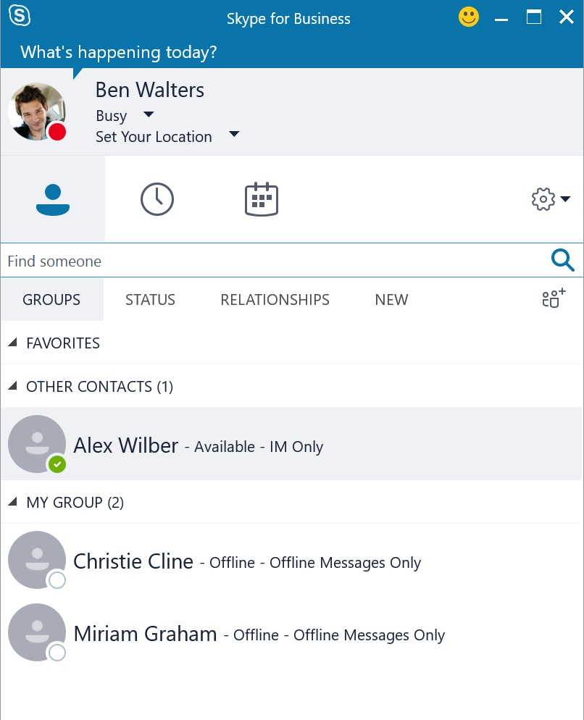

Figure 5: Presence state of Teams user from Skype for Business

From Microsoft Teams, users can search for other users within their organization who are currently only enabled for Skype for Business, and conduct instant messaging chat sessions.

Users on Skype for Business can reply to the instant messages, which will arrive in Microsoft Teams’ chat window.

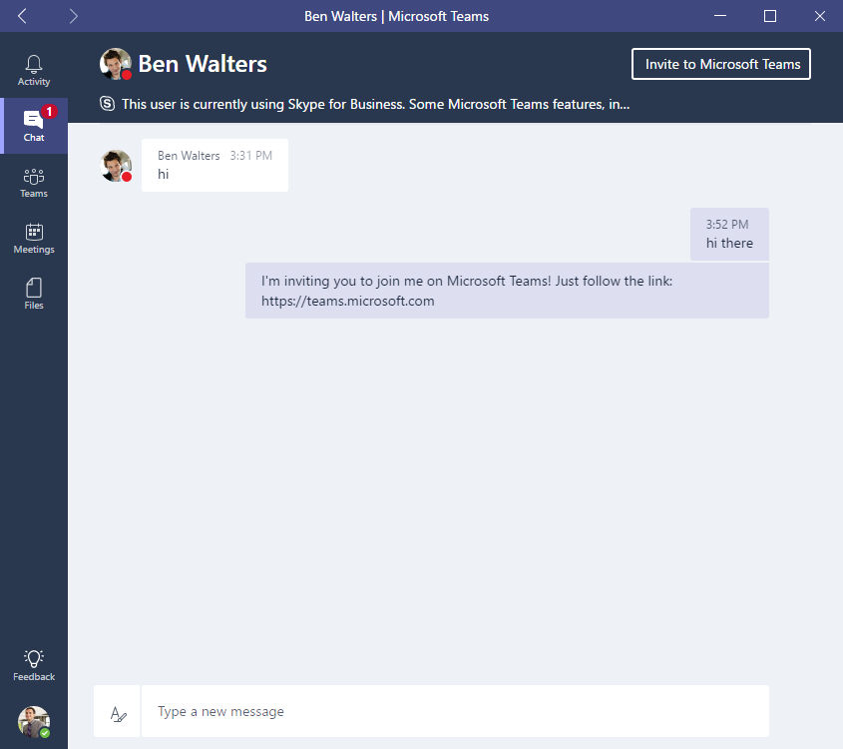

Figure 6: Communicating with Skype for Business-only user from Teams

Users on Microsoft Teams, if enabled for Skype for Business as well, can sign in to Microsoft Teams and Skype for Business using their own respective clients simultaneously.

**Note:** For a Microsoft Teams user to send an IM to a Skype for Business user, the Microsoft Teams user must be enabled for Skype for Business **with their account homed in Skype for Business Online**.

The last active endpoint will be honored, so if the user is actively using Microsoft Teams, any instant messages sent from a Skype for Business user will arrive in the Microsoft Teams chat window. If the user is currently using Skype for Business to receive/make phone calls or just finished taking a call using Skype for Business, and have not returned to Microsoft Teams client, incoming instant messages sent from a Skype for Business user will arrive in Skype for Business client as this will be the most active endpoint.

As Microsoft Teams only currently supports peer-to-peer (P2P) instant messaging interop between Skype for Business, any audio/video calls or invitation to join a Skype for Business meetings, for any modalities, from other Skype for Business users will arrive on the Skype for Business client only. In the reverse, any audio/video calls or invitation to join group calling, for any modalities from Microsoft Teams client, will only arrive on the Microsoft Teams client.

With the above behavior, end users can comfortably use both Microsoft Teams and Skype for Business at the same time, and handle specific communications needs using the right tool. However, proper end user awareness may be required to understand how interoperability works and how it may impact end user experience.

**Note**: With Skype for Business interoperability, instant messages that arrive in Teams will not be recorded in Skype for Business conversation history.

Microsoft Teams provides the ability for users to disable Skype for Business interoperability from within the Notification settings. This setting is user controlled, allowing each user to decide on the behavior they prefer.

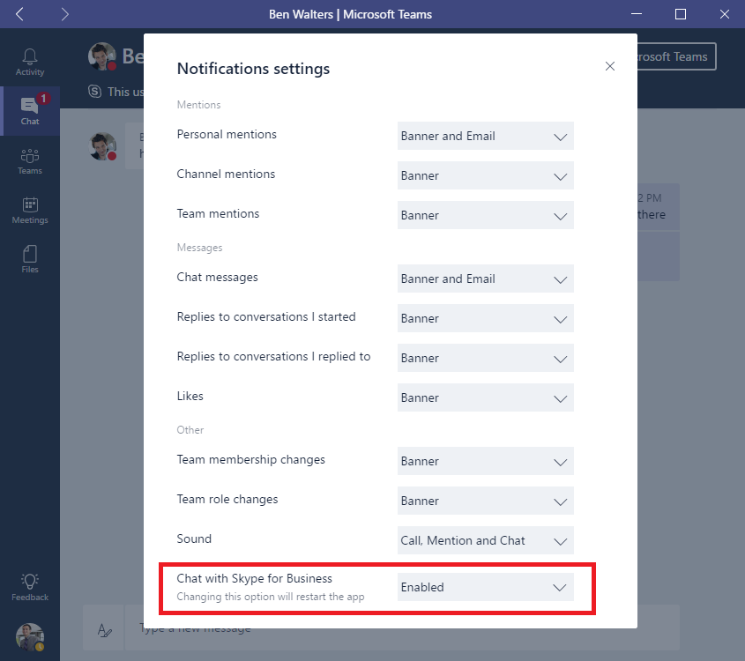

Figure 7 Skype for Business interoperability setting in Microsoft Teams

**Note:** Disabling Chats with Skype for Business can be considered to reduce impacts to end user experience when using both Skype for Business and Microsoft Teams simultaneously.

|  |  |  |
| --- | --- | --- |
|  | **Decision Point** | *Would you develop a plan to raise the awareness about Skype for Business interoperability in Microsoft Teams?* |
|  | **Next Steps** | *Document the approach your organization will take regarding enduser notification around Skype and Microsoft Teams interoperability.* |

## End User Awareness and Adoption

### Change Management

A change management strategy for end user awareness and adoption of new technologies is critical to the successful rollout of any new technology in an organization. Successful completion of this phase of the deployment will ensure user adoption and satisfaction of the new experience.

We have identified core best practices in this area:

1. Identify your key stakeholders and user audiences
2. Identify & select your business outcomes
3. Design, launch and manage your adoption campaign including:
   1. Internal awareness materials such as posters, digital signage and events
   2. Incorporate self-help and training information in a single location
   3. Select success measures
4. Build a champion program
5. Provide a standard feedback method
6. Measure & share success
7. Adjust your messaging and methods based on feedback, repeat.

#### Identifying Key Stakeholders, Users and Champions

The first rule of a successful adoption, is to create a dynamic team comprised of key stakeholders and the right people that can drive and effect change in others. A successful adoption strategy starts with a team of committed individuals representing a cross-section of your organization. Key stakeholder roles include an Executive Sponsor, Service Owners, IT professionals and Champions.

* **Executive Sponsors** are key leaders within the organization and their participation is essential in driving employee adoption. They have the greatest influence on company culture and can actively communicate the value and benefits of a new technology and way of working throughout the organization.
* **Service Owners** are responsible for ensuring people use the service and get value from it. Setting Service Owners within your organization is important to ensure the business goals set for Office 365 are realized.
* Gaining buy-in from every user across an organization is a challenge. **Champions** can help alleviate this challenge and play an important role in the adoption of Office 365. They are knowledgeable, committed to furthering their expertise and are willing to provide peer coaching and assistance. They help translate Office 365 into the reality of their department or team.

We recommend a regular meeting of these stakeholders to keep them up to date on the progress of your program. Initiating a “collaboration council” to allow for feedback and discussion can be a useful tool depending on your corporate culture.

|  |  |  |  |  |
| --- | --- | --- | --- | --- |
|  | |  | | |
| **Tip** | | *Those people who may be the biggest obstacles to change can become your best allies in a deployment of this kind. We encourage you to engage with these members of your organization early and often to hear their concerns and issues. Often, they have valuable feedback that will make your campaign more successful.* |

###### User Profiles

It is equally important to understand the types of users in your environment. Do you have users who are primarily mobile? Some who are in constant meetings or giving presentations? Do you know which of your users have the most difficulty with your existing collaboration solutions? Segmenting your user community can help you find groups that are most open to change. They are often the best targets for your early business pilots and their feedback is extremely valuable.

Understanding the day in the life of your users will help you to prioritize your business outcomes, design adoption goals appropriate for your deployment and sustain usage over time.

###### Champions

Identifying the individuals who can become your collaboration champions provides you with an extended support team for your implementation. Create a community by providing them early insight and feedback to your plans. Any investment you make in this community whether it be time, attention or rewards will be returned to your implementation through their support and evangelism.

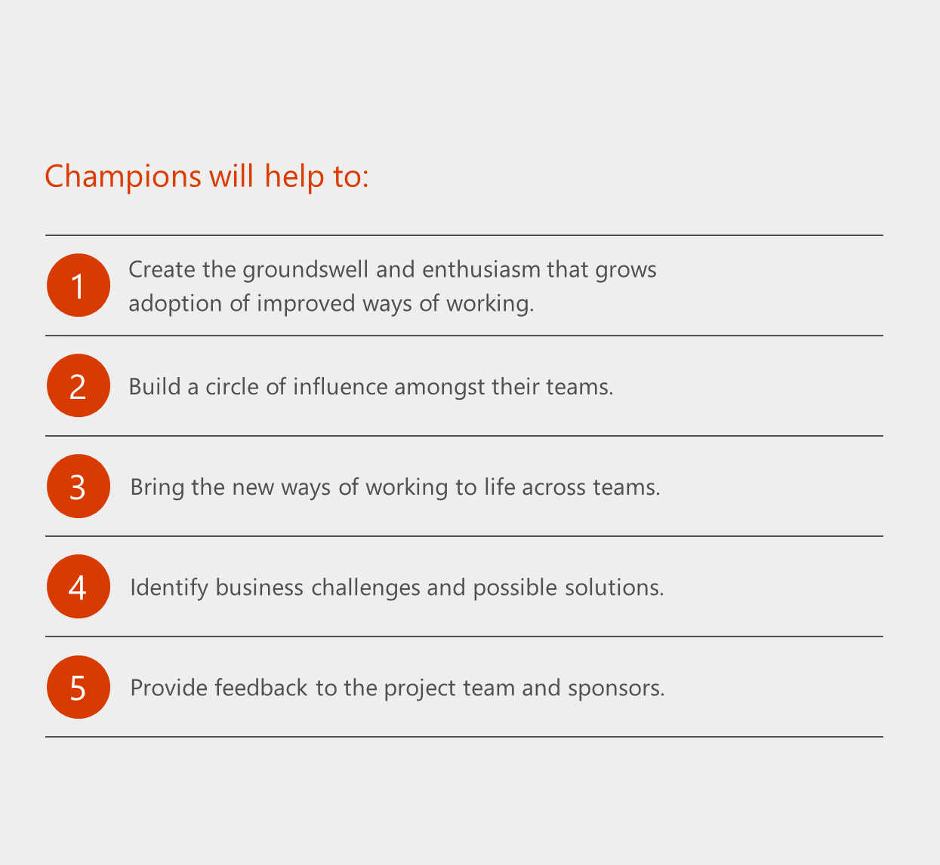

*Figure 8: Champion helpers*

Learn more about creating a champion program with this [FastTrack resource](https://view.officeapps.live.com/op/view.aspx?src=https://fto365dev.blob.core.windows.net:443/media/Default/DocResources/en-us/Adoption/Build_Champions_Program_Guide.pptx).

#### Identify & Select your Business Outcomes & Success Measures

Once you have identified your key stakeholders and user segments, identifying your business outcomes will be that much easier. Here are a few examples of business outcomes:

* Empower your employees
* Transform your Products
* Engage your customers
* Optimize Operations

Are you sales people having trouble coordinating to provide a great experience? Do you need to have better coordination in delivering your product or service? What about HR related experiences for your own employees. Each organization will find their own priorities. We recommend selecting no more than 3 to address in your initial pilots.

It is also wise to consider the users who are embedded in these scenarios. Are they open to change? Are they mobile users or within your facility? How close are they to the hub of the executive sponsors and champions that will support them and do they have any existing community and communications methods you can use to evangelize this change?

Technology projects become challenged when little or no attention is paid to the human change management requirements. By following these recommendations, you will enhance your chances for success!

#### Design, Launch and Manage your Adoption Campaign

For both your initial pilots and your eventual company-wide roll out, your internal communications should be a priority. They include:

* Internal awareness materials such as posters, digital signage and events.
* Incorporate self-help and training information in a single location.

For your pilot phases these are the minimum steps for success:

* Have a regular scheduled meeting with your project stakeholders for updates.
* Utilize a feedback method to gather information from people participating in the pilot. Companies can use a public channel within Microsoft Teams to allow users to join and provide feedback.
* Make self-help documentation available including product videos.
* Hold a kick off meeting with the pilot users to get them excited about their participation. Creating a sense of community with enthusiasm cannot be underrated.

Once you have worked through the initial pilot phases, the steps above can be expanded to reach your entire organization. Depending on your size this may take time and be approached in phases by region, user profile or organization. Within this larger scale roll out leveraging the professional talent of the communicators in your organization is extremely helpful. We recommend these individuals be involved early and often as you utilize the available adoption materials or design your own.

If your company has a central intranet portal for news, information or support you can utilize this as a hub for information on this roll out. Providing widely available self-help information, training and written guidance will enable users to quickly onboard to the product. Many users will simply jump in once it becomes available and we encourage this. We also know that each individual learns in different ways – so having a central information portal will support all styles of learning within your organization.

As with any communications & adoption campaign you will want to identify your success measures up front. Consider measures like:

* Active users in the product
* Views of your information webpages
* Questions in your user community
* Views of your training videos
* Attendance at learning events

#### Collecting Feedback & Sharing Success

The adoption of a new collaboration experience is about changing the behavior of your users. Human change requires training, encouragement and positive examples. It is also critical for people to feel heard during the transition. If you have previously established successful feedback methods in your organization, consider expanding them to include your Teams implementation. If you have not done this before, consider one of the following approaches:

* Creating a public team within Microsoft Teams that any user can join to provide feedback on their experience (keeping in mind that public groups is currently only limited to 999 users).
* Using Yammer to provide an open community for best practices and support for the experience.

Community-driven feedback methods require champions and service owners to be engaged. We recommend creating a monitoring schedule that rotates amongst these members. One best practices, is to create a separate team within Microsoft Teams as a place where these champions can collaborate, share resources, and best practices before sharing these with the broader team. The champions perform an advisory role to users adopting the new service, provide a friendly, human face to the change and collaborate with other members of your deployment team to raise and resolve issues.

###### Showcases

As you continue along this journey, you will find showcases in your own environment of employees whose creativity with Microsoft Teams will surprise and delight you. We recommend that you share these showcases broadly. This will encourage others to be innovative, educate users who may be earlier in the adoption curve and reward those who’ve taken the time to think through how to best use Microsoft Teams in their environment. Setting a measurable goal of identifying a set number of showcases each quarter is helpful in maintaining your adoption momentum.

#### Customer Success Kit

Microsoft has provided tools to assist your organization with the successful rollout of Microsoft Teams for your organization. This includes email templates for announcements, flyers, posters, and countdown and tips and tricks email. It also includes Getting Started Guides for Team Leaders and IT Administrators. Download the assets here: <https://www.microsoft.com/en-us/download/details.aspx?id=54244>

#### Learn, Adjust and Repeat:

As you go through the steps recommended here using the Customer Success Kit resources your stakeholders, champions and users will share feedback. These valuable insights can assist you in adjusting your approach, messaging and models to drive additional adoption and ultimately land your business outcomes. Flexibility in an agile service management model is critical in delivering success at the pace of business today. If you are reading this document, you are one of the core individuals responsible for the success of this deployment and your ability to adjust your plan based on current conditions will accelerate the adoption curve in your company.

Microsoft Teams is designed to foster collaboration while being a simple to use yet robust service. Periodically revisiting the business outcomes, you selected at the beginning of this journey will ensure that you are delivering measurable business impact within those priorities through the adoption of Microsoft Teams.

|  |  |  |
| --- | --- | --- |
|  | **Decision Point** | * *What is your change management strategy?* * *How has your organization handled change management for other technology rollouts?* * *Who are your executive sponsors, champions, Service Owners/IT Admins that will influence how successful Teams is in your organization?* * *Who will be your pilot group?* |
|  | **Next Steps** | * *Establish a change management and adoption strategy for Microsoft Teams using the best practices.* * *Introduce the champions, team leaders to your strategy, the Customer Success Kit and the Getting Started Guides to begin building the internal team of champions for Microsoft Teams.* |

### Support Documentation

The following are resources available to assist with the deployment of Microsoft Teams:

* [Frequently Asked Questions](https://support.office.com/en-US/article/Frequently-asked-questions-about-Microsoft-Teams-%25E2%2580%2593-Admin-Help-05cbe533-2181-4e95-a4b0-52cd7695fafc?ui=en-US&rs=en-US&ad=US)
* [Administrator Settings for Microsoft Teams](https://support.office.com/en-US/article/Administrator-settings-for-Microsoft-Teams-3966a3f5-7e0f-4ea9-a402-41888f455ba2)
* [End User Help](https://support.office.com/en-us/teams)
* [Known Issues](https://aka.ms/teamsissuelist)

### T-Bot

For help while using Microsoft Teams, ensure your users and champions get familiar with T-Bot. T-Bot is a bot which can answer a wide range of questions that you may have about using Microsoft Teams. The following is an example of the guidance from T-Bot on tips and tricks for managing channels:

1. Arrange your Teams in an order that makes sense to you, putting the busiest Teams at the top of your list.
2. Favorite the Channels you use the most. This way, they'll stay visible in your Team list, and you'll see when new messages have been posted.
3. @mention people so they @mention you. You'll see you've been @mentioned in your notifications. Also, a red circle with a number in it will appear next to the Channel name.
4. Keep an eye on your notifications  . That lets you know whenever you've got notifications of actions / conversations.

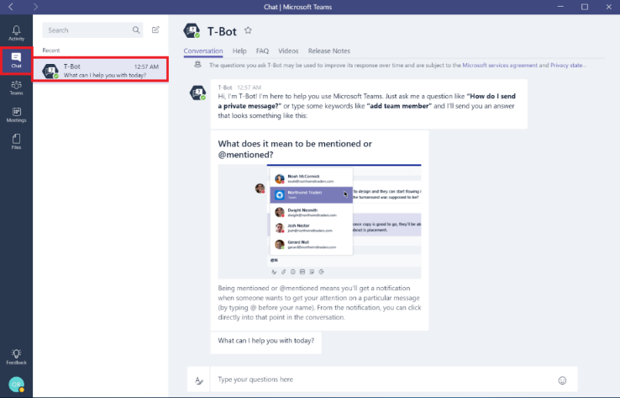

Figure 9: The T-Bot

# Deliver

## Prerequisites to Microsoft Teams Deployment

### Networking

Below are areas to ensure that your infrastructure meets the requirements to achieve a successful deployment of Microsoft Teams

#### External Name Resolution

Ensure that all the client computers running Microsoft Teams client can resolve external DNS queries to discover the services provided by Office 365.

#### URLs and IP Addresses:

Ensure that all recommended ports are allowed on the firewalls and URLs to service are allowed. Please refer to Network Planning section above for the list of IP addresses and URLs that covers the IP addresses and ports to be allowed, and URLs that need to be whitelisted through the proxy solutions and to be added to Internet Explorer Trusted Sites Zone of the client computers.

Microsoft is continuously improving the Office 365 service and adding new functionalities, therefore the required ports, URLs and IP addresses may change over time. Please refer to [Office 365 URLs and IP address ranges](https://support.office.com/article/Office-365-URLs-and-IP-address-ranges-8548a211-3fe7-47cb-abb1-355ea5aa88a2) guide for the latest versions of ports and protocols. It is also highly recommended to [subscribe via RSS](https://go.microsoft.com/fwlink/p/?linkid=236301) to receive notifications when endpoints are updated or changed.

For all Office 365 workloads, the recommended connection method to Microsoft Teams services is bypassing the forward proxy where possible. When a proxy server sits between a client and the Office 365 datacenters, media might be forced over TCP instead of UDP, that would impact media quality. A sample proxy PAC files that can be used to configure traffic bypass can be downloaded from [Managing Office 365 endpoints](https://support.office.com/article/managing-Office-365-endpoints-99cab9d4-ef59-4207-9f2b-3728eb46bf9a) guide.

If your networking and security policies require Office 365 traffic to flow through a proxy server, then make sure that the above requirements are already met before deploying Microsoft Teams into production (review [Proxy Servers for Skype for Business Online](https://support.office.com/en-us/article/Proxy-Servers-for-Skype-for-Business-Online-7acaf2c2-35fa-490f-84cd-822e446e0fc7?ui=en-US&rs=en-US&ad=US) for guidance.)

#### NAT Pool Size

When multiple users/devices access Office 365 using Network Address Translation (NAT) or Port Address Translation (PAT), you need to ensure that the devices hidden behind each publicly routable IP addresses do not exceed the supported number.

To mitigate this risk, ensure adequate Public IP addresses are assigned to the NAT pools to prevent port exhaustion. Port exhaustion will cause internal end users and devices to face issues when connecting to the Office 365 services. For more information, please refer to [NAT support with Office 365](https://support.office.com/article/NAT-support-with-Office-365-170e96ea-d65d-4e51-acac-1de56abe39b9) guide.

#### Intrusion Detection and Prevention Guidance

If your environment has an Intrusion Detection and/or Prevention System (IDS/IPS) deployed for an extra layer of security for outbound connections, ensure that any traffic with destination to Office 365 URLs is whitelisted.

## Microsoft Teams Configuration

### Tenant-level Enablement

Microsoft Teams is enabled by default for organizations who have not tried Microsoft Teams during the preview. For organizations who have been testing in preview, the setting will remain as what was set prior to general availability of Microsoft Teams.

Organizations who wish to change whether Microsoft Teams is enabled or not can follow the steps below to in their Office 365 tenant:

1. Sign in to [Office 365 Admin Center](https://portal.office.com/adminportal/home) with an account that has Global Administrator privileges.
2. Navigate to **Settings 🡪 Services & add-ins.**

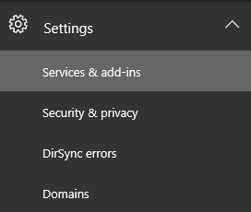

Figure 10: Services & add-ins Settings

1. On the Services & add-ins page, click Microsoft Teams.

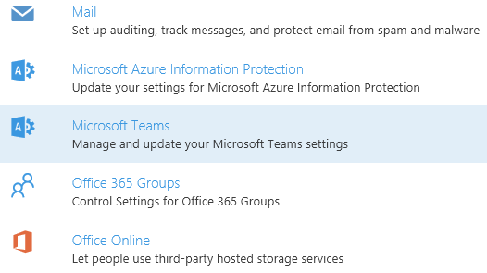

Figure 11: Services & add-ins – Microsoft Teams

1. To enable Microsoft Teams for the organization, set the **Toggle** to **On** and then click **Save**.

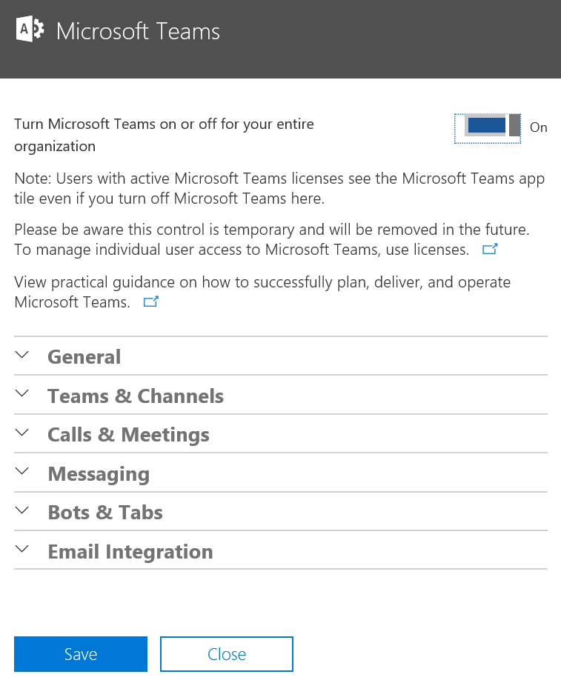

Figure 12: Microsoft Teams Settings

**Note:** The tenant-level capability to control the on/off status of Microsoft Teams is temporary and will be removed at some point in the future. At that time, access to Microsoft Teams will be controlled via user level licensing only.

### User-level Enablement

Microsoft Teams user level licenses are managed through the Office 365 Admin Center user management interfaces. An administrator can assign licenses to new users when new user accounts are created, or to users with existing accounts. The administrator needs to have Office 365 Global Administrator or User Management Administrator privileges to manage Microsoft Teams licenses.

When a license SKU like E3 or E5 is assigned to a user, a Microsoft Teams license is automatically assigned, and the user is enabled for Microsoft Teams. Administrators can have a granular control over all the Office 365 services and licenses, and the Microsoft Teams license for a specific user or a group of users can be enabled or disabled.

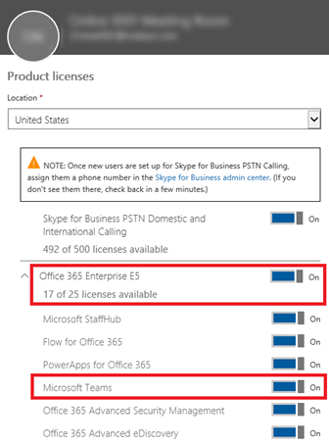

Figure 13: License Assignment with a license SKU

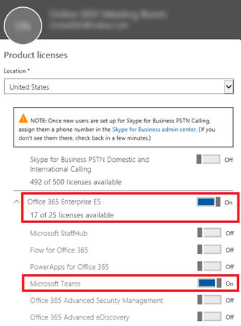

Figure 14: Enabling a user license for Microsoft Teams

A Microsoft Teams user license can be disabled at any time. Once the license is disabled, the users access to Microsoft Teams will be prevented and the user will no longer be able to see Microsoft Teams in the Office 365 app launcher and homepage.

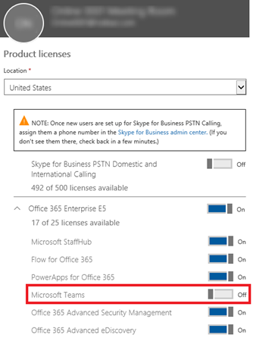

Figure 15: Disabling a user license for Microsoft Teams

User licenses can also be assigned and removed by using PowerShell. Please refer to [Assign licenses to user accounts with Office 365 PowerShell](https://technet.microsoft.com/library/dn771770.aspx) or [Remove licenses from user accounts with office 365 PowerShell](https://technet.microsoft.com/en-us/library/dn771774.aspx) for details and sample PowerShell cmdlets.

## Groups, Roles and Permissions

### Office 365 Groups

A new Office 365 group is provisioned automatically for each new team created using Microsoft Teams client.

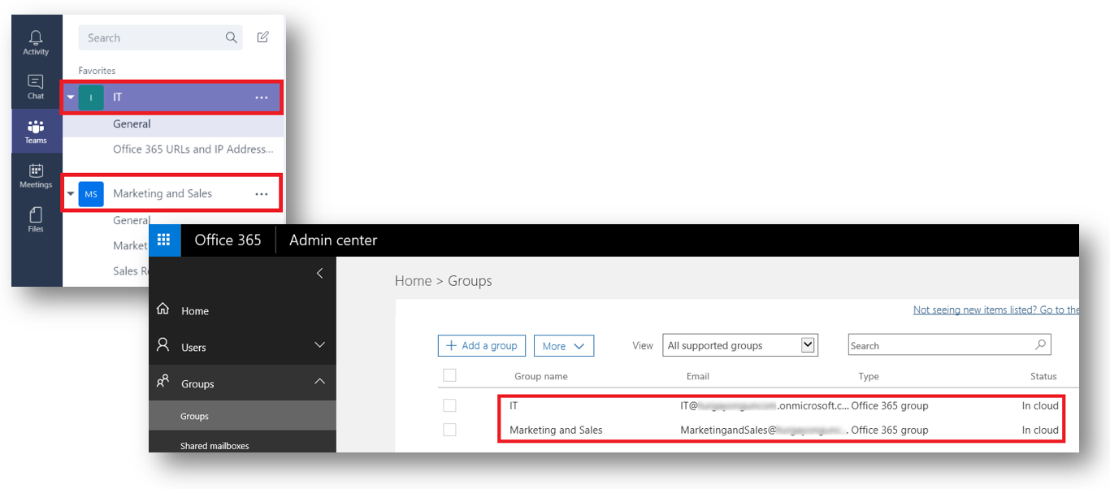

Figure 16: Office 365 Groups provisioned by Teams

Role assignments that are defined for a team are propagated to the relevant group in Office 365 Groups. Owners and members can be easily managed through the Microsoft Teams client. (See - Assign Roles)

Note: When an Office 365 Group is enhanced with Microsoft Teams, administrators can still manage membership in the Office 365 Groups admin portal and changes will sync to Teams on a 60-minute interval.  However, we highly recommend that you do management of teams within the Microsoft Teams client.

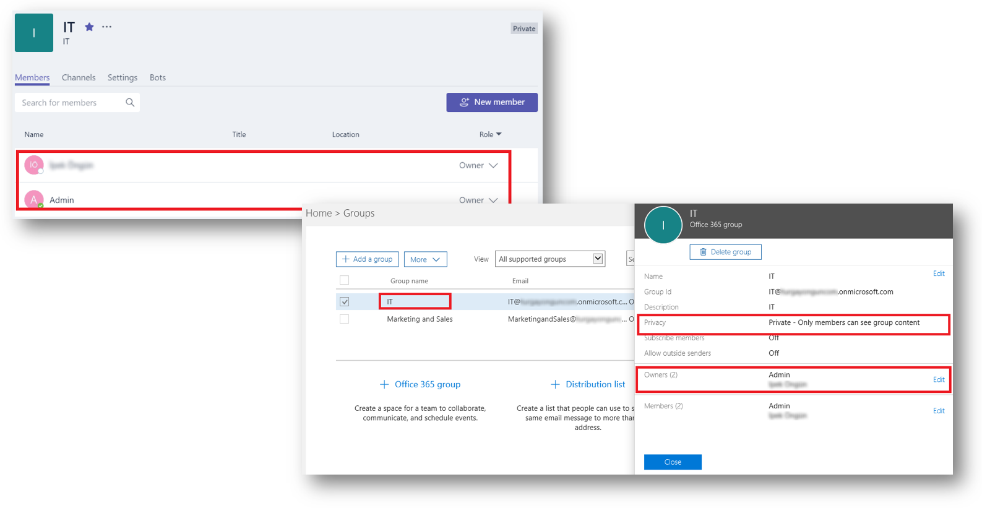

Figure 17: Office 365 Groups provisioned by Teams

#### Enhancing Existing Office 365 Groups with Microsoft Teams

Microsoft Teams users can enhance an existing Office 365 Group with Microsoft Teams functionality. When looking at enhancing a public Office 365 Group, users are only able to do that if the number of members is equal to or less than 999.

To do this, users should go through the flow of creating a new team from the Microsoft Teams client, select “Yes, add Microsoft Teams functionality” at the bottom of the screen and then choose the existing group that they want to enhance with Microsoft Teams. Existing group members will be added as members to the team automatically.

**Note:** Only the group owners have permission to enhance an existing group with Microsoft Teams.

Users can also invite a distribution list to a team, and the members of that distribution list will be added to the team. This is a one-time sync, and later changes in group membership in the distribution list will not be replicated to Teams.

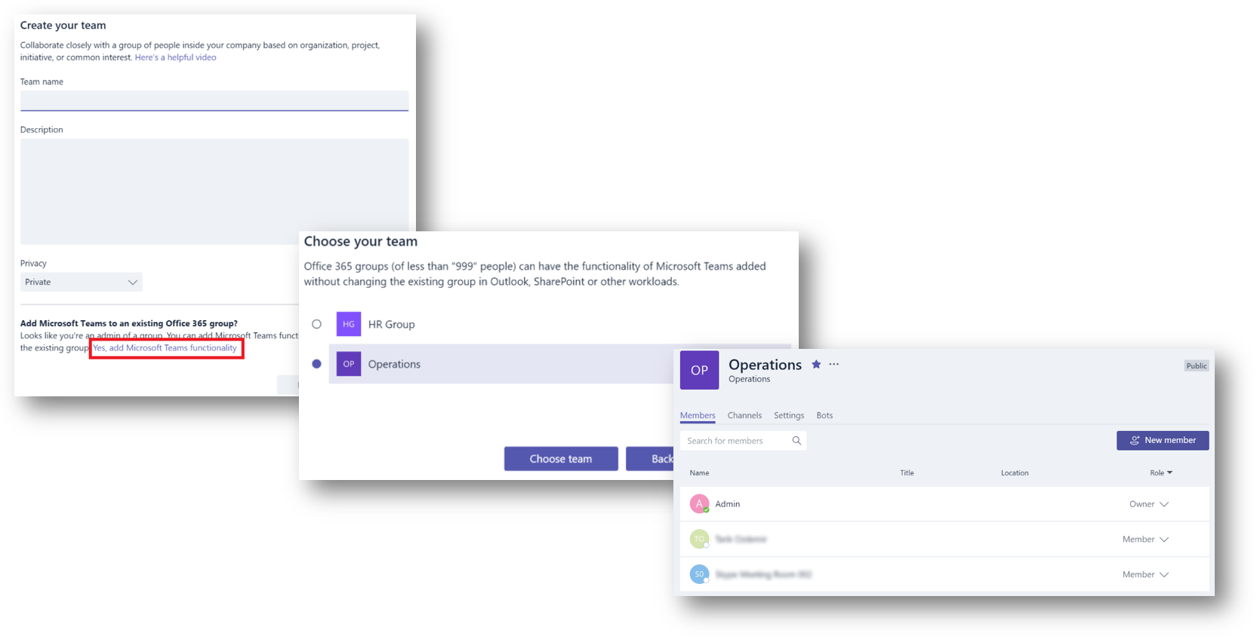

Figure 18: Converting existing groups into Teams

There are two types of privacy settings with Office 365 groups, public and private. Whereas both group types can be enabled for Microsoft Teams, there is a slight difference when it comes to self-service.

* Users can search for public groups and able to join by themselves without a need for team owner’s approval.
* Private groups are not searchable, and users cannot join unless a team owner add them as a member.

### Roles and Permissions Delegation

A user that creates a team is assigned an owner role with all permissions on that team as well as the Office 365 group that is linked to that team.

By default, all users with a mailbox in Exchange Online have permissions to create Office 365 Groups and therefore a team within Microsoft Teams. You can have tighter control and restrict the creation of new teams and thus the creation of new Office 365 Groups by delegating group creation and management rights to a set of users.

If your organization is interested in doing this, the table below outlines the tasks required to do so.

*Table 12 – Restricting and Delegating Office 365 Group/Microsoft Teams team creation*

|  |  |  |
| --- | --- | --- |
| Task | Action | Reference |
| Identify or create a security group of users that will have delegated permission to be able to create groups. | Set up a security group in Office 365 to which you can add all your users that you want to be able to create Office 365 Groups | [Create, edit, or delete a security group in the Office 365 admin center](https://support.office.com/article/Create-edit-or-delete-a-security-group-in-the-Office-365-admin-center-55c96b32-e086-4c9e-948b-a018b44510cb) |
| Verify that the company-wide control for users to create groups is enabled | Run the following PowerShell script and verify UsersPermissiontoCreateGroupsEnabled parameter is set to True  Connect-MsolService  Get-MsolCompanyInformation  If not, run the Set-MsolCompanySettings cmdet to set it to True.  Set-MsolCompanySettings -UsersPermissionToCreateGroupsEnabled $True | [Manage Office 365 Group Creation](https://support.office.com/en-us/article/Manage-Office-365-Group-Creation-4c46c8cb-17d0-44b5-9776-005fced8e618?ui=en-US&rs=en-001&ad=US#checkclevelsettings) |
| Configure Office 365 Group settings to allow only identified security group has permissions to create groups | Create a group settings object that will contain the configuration settings of the group that will be assigned delegated permissions to create groups.  Connect-MsolService  Get-MsolGroup -SearchString "<Group Name>"  $template = Get-MsolAllSettingTemplate | where-object {$_.displayname -eq "Group.Unified"}  $setting = $template.CreateSettingsObject()  $setting["EnableGroupCreation"] = "false"  $setting["GroupCreationAllowedGroupId"] = "<object ID for your group>"  New-MsolSettings -SettingsObject $setting | [Manage Office 365 Group Creation](https://support.office.com/en-us/article/Manage-Office-365-Group-Creation-4c46c8cb-17d0-44b5-9776-005fced8e618?ui=en-US&rs=en-US&ad=US#step3) |

## Microsoft Teams Client Deployment, Updates and Security

In this section, we will cover the various aspects of deployment, update and security management applicable to the Microsoft Teams clients.

### Client Deployment

The Microsoft Teams client is a web download that can be obtained by logging into <https://teams.microsoft.com> and clicking on **Download** in the upper right hand corner on the screen.

If not presented with the option to download, users can download the desktop app by navigating directly to the download page: https://teams.microsoft.com/downloads.

### Desktop Clients

IT admins can choose their preferred method to distribute the installation files to machines in their organization such as System Center Configuration Manager (Windows) or Casper Suite (MacOS).

**Note:** this is only for the initial installation of Microsoft Team clients and not for future updates.

#### Windows

The Microsoft Teams installation for Windows provides downloadable installers in 32-bit and 64-bit architecture. The architecture should match that of the operating system, which is what the online download will default to.

**Note:** the architecture (32-bit vs. 64-bit) of Microsoft Teams is agnostic to the architecture of Office that is installed.

The Windows client is deployed to the AppData folder located in the user’s profile. Deploying to the users’ local profile allows the client to be installed without requiring elevated rights. The Windows client is installed in the following locations:

* %appdata%\local\Microsoft\Teams
* %appdata%\roaming\Microsoft\Teams

When users initiate a call using the Microsoft Teams client for the first time, they might notice a warning with the Windows firewall settings that asks for users to allow communication. Users may be instructed to ignore this message because the call will work, even when the warning is dismissed. Alternatively, IT Admins can choose to add a Windows firewall exception to an existing GPO policy to prevent the Windows firewall prompt from occurring on Windows PCs.

#### Mac

Microsoft also provides a DMG installation file for Mac OSX computers. Administrative access is required to install the Mac client. The Mac OSX client is installed to the following location:

~/Library/Application Support/Microsoft/Teams

#### Mobile Clients

To get the most recent mobile versions of Microsoft Teams, administrators or users can install the mobile clients using the relevant mobile store for Google Play, Apple App Store, and Microsoft Store.

#### Web Client

There is no plugin or download required to leverage Microsoft Teams using a web browser. The section above on Web Client outlined the browser requirements for Microsoft Teams.

### Client Update Management

Clients are currently updated automatically by the Microsoft Teams service with no IT administrator intervention required. If an update is available, the client will automatically download the update and when the app has been idled for a period of time, the update process will kick off.

### Client Security Management

In this section, we will cover the aspects of Mobile Device Management (MDM), Mobile Application Management (MAM) and Conditional Access for Microsoft Teams.

#### MDM

IT administrators can make the Microsoft Teams client more secure by enforcing restrictions on managed devices through the Office 365 Security and Compliance Center or Intune.

The following table outlines the differences in capabilities when leveraging MDM via Office 365 and Intune.

Figure - MDM via Office 365 and Intune

|  |  |
| --- | --- |
| MDM for Office 365 | MDM with Intune |
| * Managed through Office Security and Compliance Center * Mobile Devices only * Target User/Device Policies * Device Reporting * Selective Wipe of Data * Device Encryption, Password Policies, blocking screenshots | * All of MDM for O365 plus * Managed through Intune admin console * Restrict of Cut/Copy/Past actions * Managed Browser app * Full support for PCs, Macs, Linux and Unix machines * Conditional Access * Mobile Application Management |
| * Included with Office 365 Commercial Subscriptions | * Included with Enterprise Mobility Suite or Intune/Azure AAD Premium |

**Note:** Intune based Mobile Application Management (MAM) is supported for the Microsoft Teams app on iOS and Android. MAM is not applicable to non-mobile devices.

Below are links to help you learn more about Office 365 and Intune’s features and capabilities:

* [Choose between Office 365 and Intune](https://docs.microsoft.com/en-us/intune/deploy-use/protect-app-data-using-mobile-app-management-policies-with-microsoft-intune)
* [Office 365 MDM](https://support.office.com/en-us/article/Overview-of-Mobile-Device-Management-MDM-for-Office-365-faa7d8e5-645d-4d59-839c-c8d4c1869e4a?ui=en-US&rs=en-US&ad=US)
* [Intune MDM](https://docs.microsoft.com/en-us/intune/understand-explore/introduction-to-microsoft-intune)
* [Intune MAM](https://docs.microsoft.com/en-us/intune/deploy-use/protect-app-data-using-mobile-app-management-policies-with-microsoft-intune)

#### Conditional Access

Conditional Access for the Microsoft Teams client is supported through Intune.  If the organization enables Conditional Access, for either Exchange Online or SharePoint Online in Intune, mobile users will be required to sign into Microsoft Teams mobile app from an Intune enrolled and compliant mobile device. Conditional Access is supported for mobile devices only. Teams.microsoft.com on web browsers will support Conditional Access through the [Intune managed browser](https://docs.microsoft.com/en-us/intune/deploy-use/manage-internet-access-using-managed-browser-policies).

Learn more about Intune’s [Conditional Access](https://blogs.office.com/2016/04/28/mobile-application-management-and-conditional-access-now-available-for-skype-for-business-online-with-intune/) capabilities.

### Client Side Configurations

In this section, we will cover the selections available for managing client side configuration options. Currently, there are no supported options available to configure the client either through the tenant admin, PowerShell, Group Policy Objects or the registry.

#### Notification Settings

There are currently no options available for IT administrators to configure client side notification settings. All notification options are set by the user. The figure below outlines the default client settings.

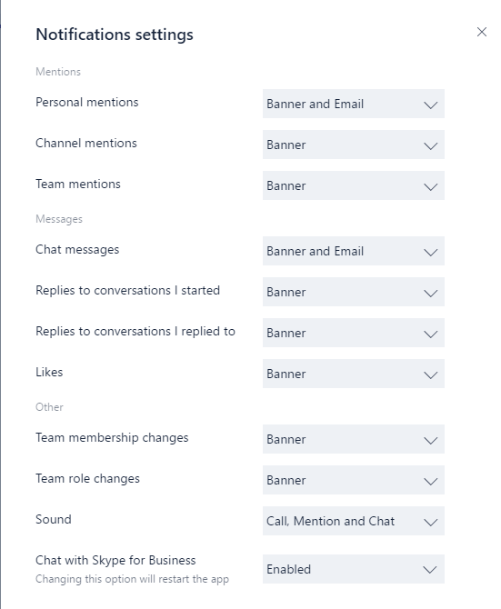

Figure 20: Client notification settings

## Extensibility

Microsoft Teams provides a canvas that can integrate with other parts of Office 365 and many third-party applications to aggregate information from different sources in order to enhance productivity. Microsoft Teams can be extended with Tabs, Connectors and Bots.

### Tabs

Tabs allow team members to access service on a dedicated canvas within a channel. This lets the team work directly with the tools and data you provide, in the channel’s context, and to have conversations about them. With every new channel, two tabs are provisioned by default:

* Conversations
* Files

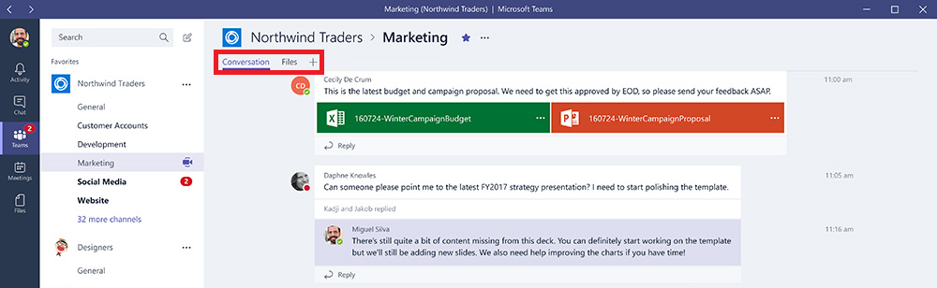

Figure 21: The default tabs

Each channel can have additional tabs that will assist team members to integrate their cloud services. Tabs can be added by members or owners of the team.

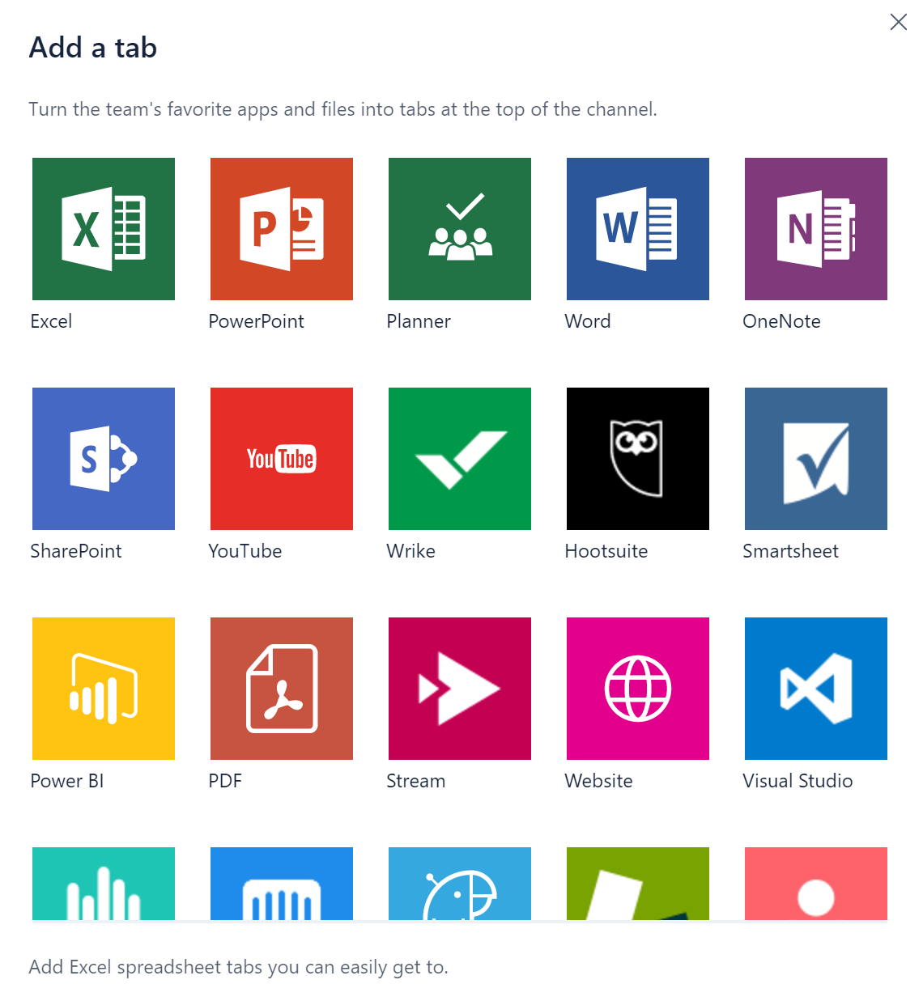

Figure 22: Adding custom tabs

Excel, PowerPoint, Word and PDF files must be uploaded to the Files tab before they can be converted to tabs. Alternatively, any existing files uploaded can be converted into tabs with a single click.

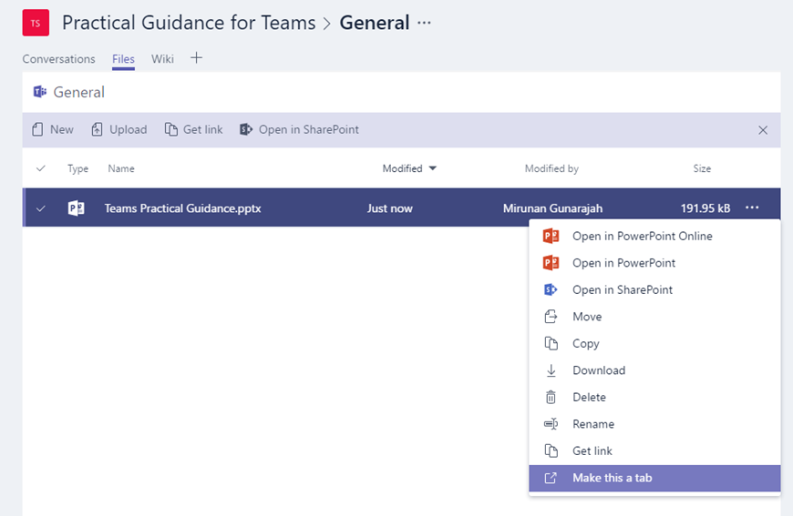

Figure 23: Converting files into tabs

To add a website, the URL must start with an https prefix so that any information exchanged can stay secure. Detailed instructions are provided when a team member is trying to add a custom tab into their channels.

With each custom tab added into a channel, a tab conversation is created that allows team members to have focused discussions about the content.

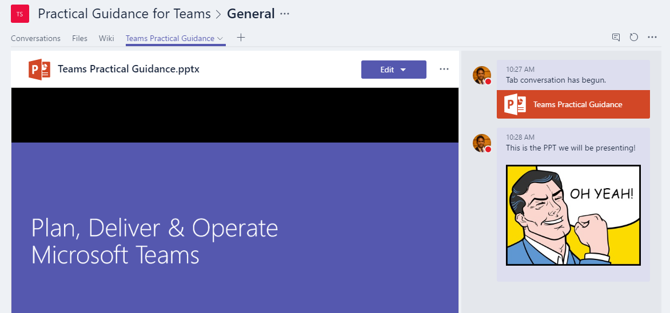

Figure 24: Tab conversations

Additional tabs can be added to channels to help users easily access the data they need or interact most. This can be a Power BI report or dashboard, or even a [Microsoft Stream](https://stream.microsoft.com) video channel where you publish training videos.

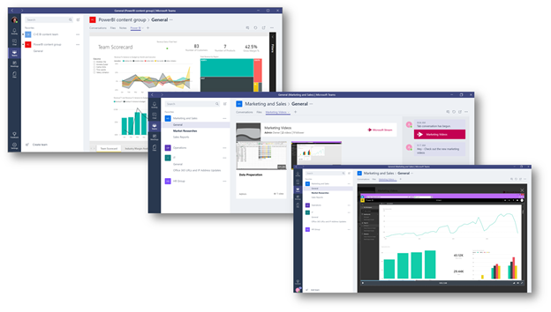

Figure 25: Power BI and Microsoft Stream integration with Teams

#### Developing Custom Tabs

In addition to the built-in tabs, organizations can easily design and develop their own tabs, that can be integrated into Microsoft Teams or even be shared with the rest of the community.

The Microsoft Developer Network provides [detailed instructions](https://msdn.microsoft.com/en-us/microsoft-teams/design) that you can use to design and build your own tabs and download and deploy [sample tabs](https://msdn.microsoft.com/en-us/microsoft-teams/samples) developed by Microsoft.

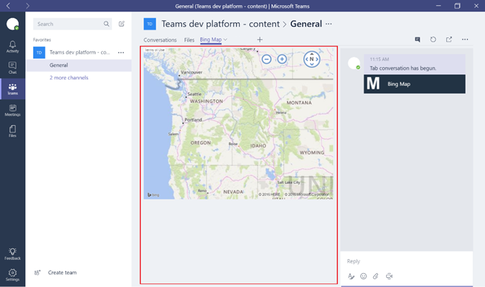

Figure 26: A sample Bing Map tab integrated into a channel

### Connectors

Connectors keep your team current by delivering content and updates from services you frequently use directly into a channel. Any member of a team can connect their team to popular cloud services with the connectors and all members of the team get notified of activities from that service. Office 365 connectors can be used with both Microsoft Teams and Office 365 Groups and make it easier to have all members stay in sync and get the relevant information quickly. Both Microsoft Teams and Exchange use the same connector model, that allows you to use the same connectors within both platforms.

Currently, connectors can be added using Microsoft Teams desktop and web clients, however information posted by these connectors can be viewed using all the clients including mobile.

1. To add a connector to a channel, simply **click** the ‘**…**’ to the right of a channel name and click **Connectors**

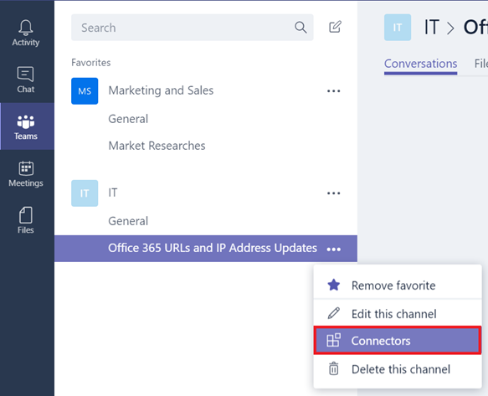

Figure 27: Integrating a channel with an Office 365 connector

1. Users can select from a variety of available connectors and click **Add**.

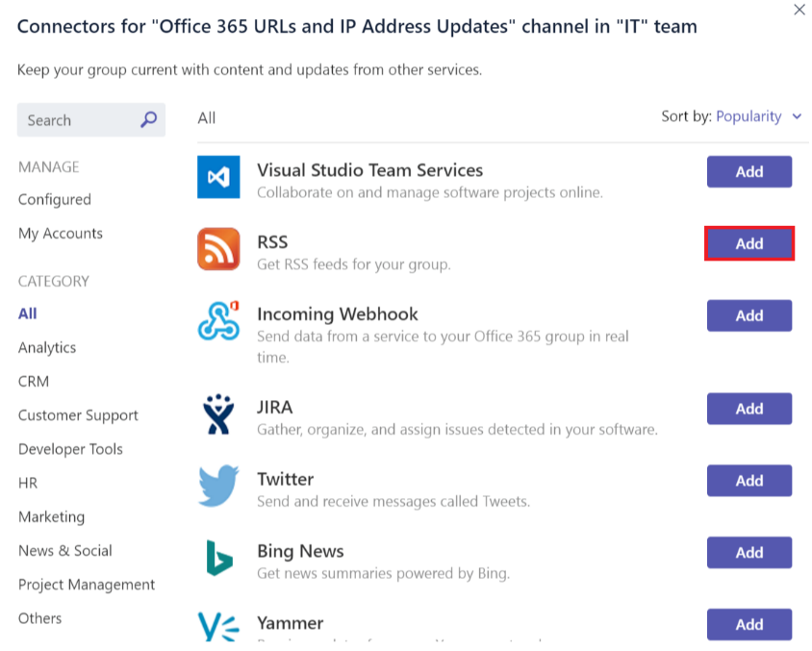

Figure 28: Available connectors are listed

1. Fill in the required information of the selected connector and click **Save**. Each connector requires a diverse set of information to function properly, and some of them may require you to sign in to the service using the links provided on the connector configuration page.

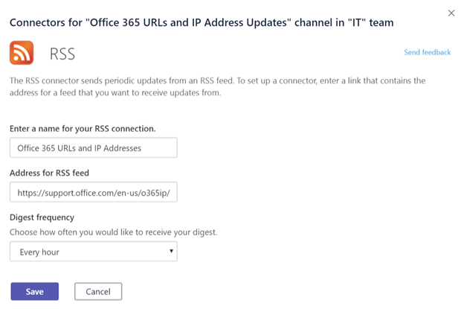

Figure 29: Configure connector settings

1. Data that will be provided by the connector will be post to the channel automatically.

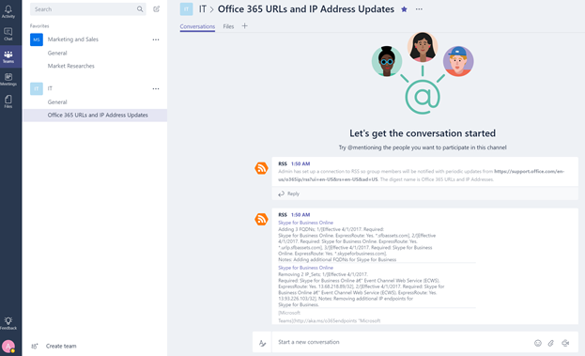

Figure 30: Connector posted data in a channel

#### Developing Custom Connectors

It is very easy to develop custom connectors that can be integrated into your Line of Business applications. You can use the built-in Incoming Webhook connector to create an endpoint for a channel that can be used to pull data from any application using HTTP post methods.

1. Add the Incoming Webhook like any other connector.



Figure 31: Incoming Webhook Connector

1. To create a webhook, specifying a name, update the image of the webhook if necessary, and click **Create**.

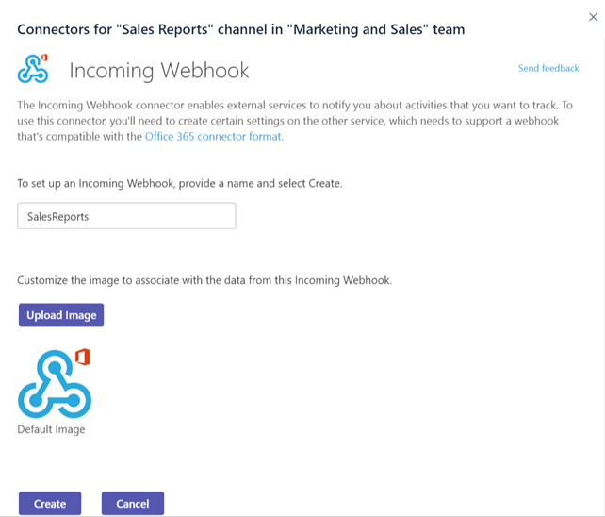

Figure 32: Specify name for the Incoming Webhook

1. Applications that will push data to this channel, will require the URL of the Webhook connector. A **unique URL** will be created when you created the **webhook**. Share this URL with your developers, so that they can configure their applications to push data as needed.

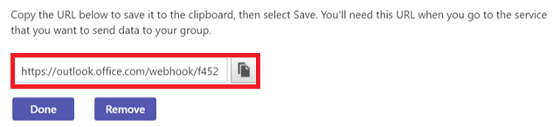

Figure 33: Get the Webhook URL

1. When an external application pushes data to a connector, the message will be shown in the channel conversation list as a special message called a “**Connector Card”** message.

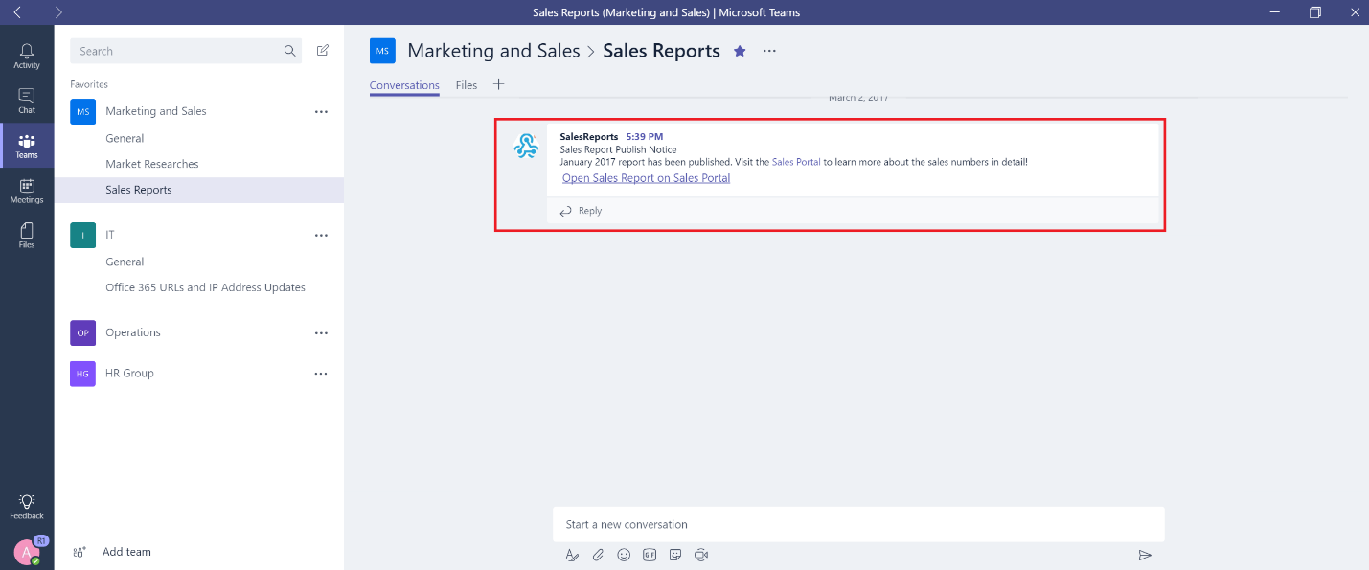

Figure 34: A sample connector that utilizes Connector Card messages

Developers can configure their applications to create these cards by sending an HTTP request with a simple JSON payload to a Microsoft Teams webhook address, that is a unique URL of that endpoint provided by the wizard. Have your developers refer to “[Getting started with Office 365 Connectors for Microsoft Teams](https://msdn.microsoft.com/en-us/microsoft-teams/connectors)” guide on Microsoft Developer Network with detailed instructions and connector samples.

### Bots

Bots are automated programs that are set up to respond to queries or give updates and notifications about things users find interesting or want to stay informed about. Bots allow users to interact with cloud services like task management, scheduling and polling, through chat conversations in Microsoft Teams. Bots for Microsoft Teams are built on the [Microsoft Bot Framework](https://dev.botframework.com) and the bots that are developed using this framework can easily be enabled for Microsoft Teams.

Currently, Microsoft Teams support bots in private chats and channels within a team.

Administrators can control whether the use of bots is allowed or prohibited within the Office 365 tenant.

#### T-Bot

By default, each user will have access to T-Bot, an embedded assistant that helps users learn how to use Microsoft Teams. Users can interact with T-Bot to ask it questions about how to use Microsoft Teams.

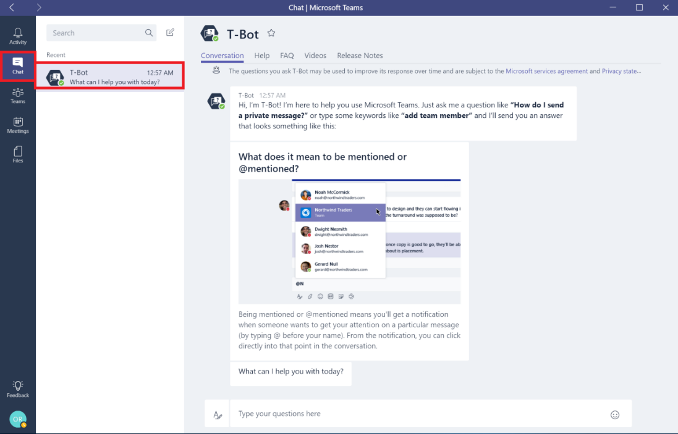

Figure 35: The T-Bot

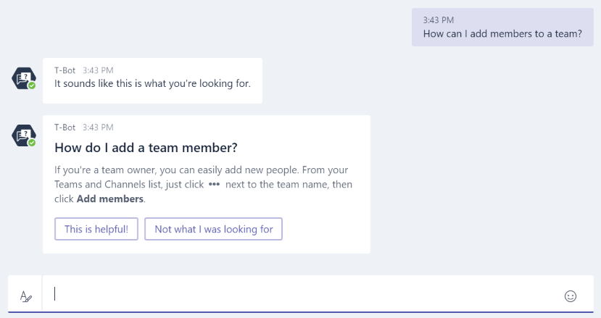

Figure 36: T-Bot interaction through chat conversations

T-Bot also provides alternative assistance methods for the users who will prefer browsing the content instead of asking questions to a bot.

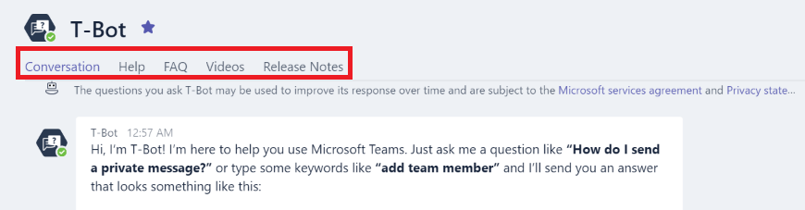

Figure 37: T-Bot interaction options

Providing a full slate of Help, FAQ, Videos and Release Notes sections via the tabs within the bot.

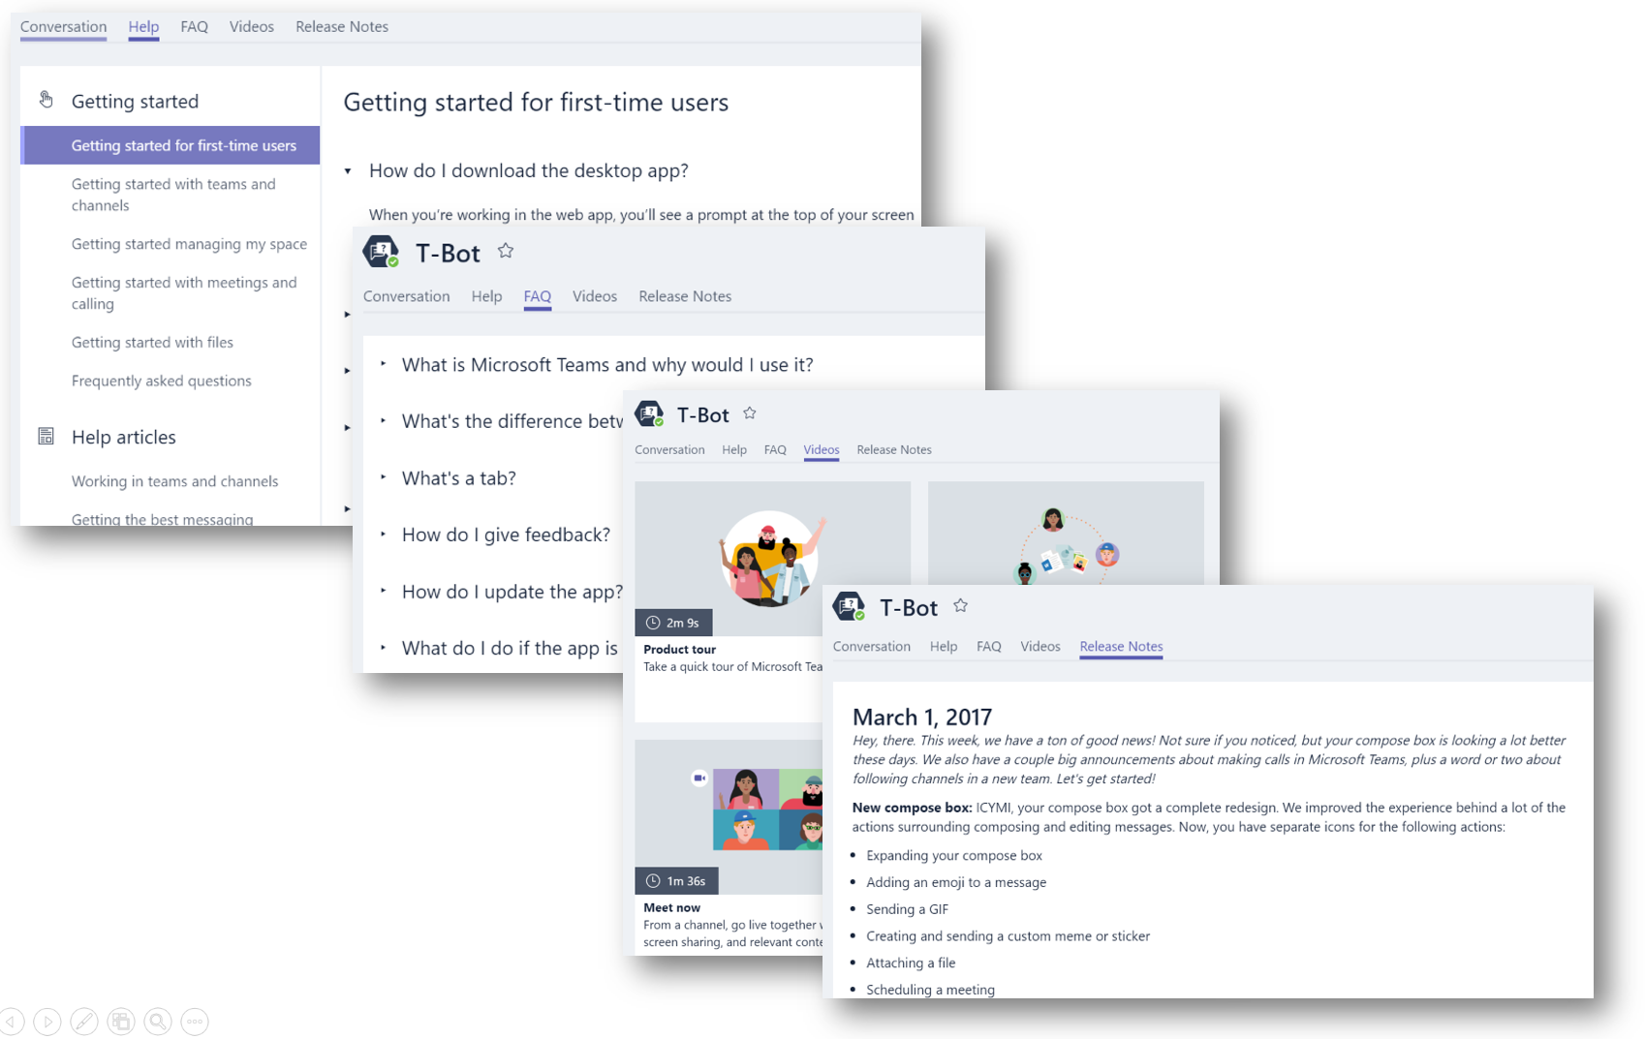

Figure 38: Browsing content using alternative T-Bot methods (Help, FAQ, Videos, Release Notes)

### Additional Bots

Bots that have been developed by the community and made available can be leveraged within Microsoft Teams. The Bots functionality and bots side loading must be enabled on the tenant level for custom bots to be functional.

Bots can be used in private chats or in channels. For channels, bots can be added as a team owners or member.

#### Adding Bots for private chat and Channels

There are two ways of integrating a bot for private chats and channels:

1. Install publicly available bots for private chat or channels:
2. Users can find bots by navigating to chat, searching for a contact and instead clicking **‘Discover bots’.**

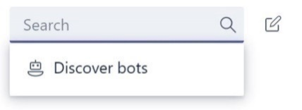

Figure 39: Add a bot to Microsoft Teams

1. Then, select which **bot** you would like to have a conversation with:

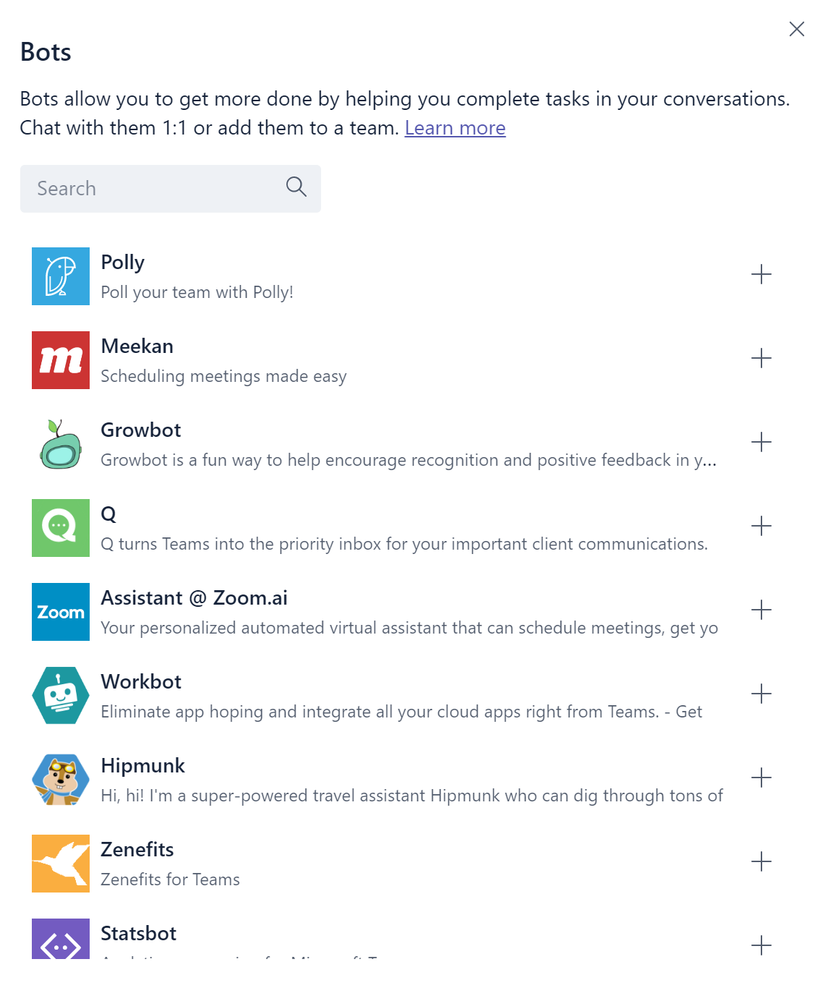

Figure 40: Select a bot you’d like to interact with

1. Once selected, provide the bot with permissions and select whether you would like to use bots in a private chat or select a Team to use it in:

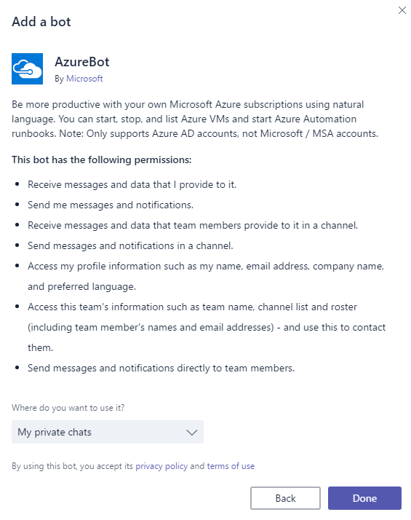

Figure 41: Provide permissions & select private chat or a channel

1. Alternatively, to use a bot within a channel of a team, simply click on **View Team** and **Bots**. Here you can Discover additional bots.
2. At any time, bot can be removed from the team. Simply click on **View Team** and **Bots** to see all bots and then **remove** the one you’d like.

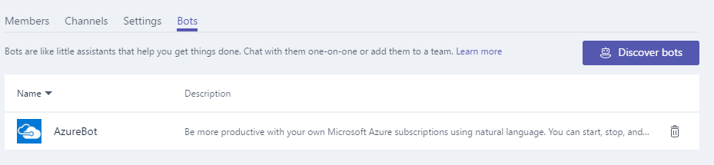

Figure 42: Removing a bot from a Team

### Developing Custom Bots

You can easily create a bot that integrates in to your Line of Business applications using the Microsoft Bot Framework. Please refer to [Creating and Testing a bot for Microsoft Teams](https://msdn.microsoft.com/en-us/microsoft-teams/botscreate) guidance to learn how you can develop and publish your own bots.

Bots can be tested using the [Bot Framework Emulator](https://github.com/Microsoft/BotFramework-Emulator) before they are deployed into your teams.

#### Side-load your own bot for private chat:

1. Once you have created your Bot, navigate to the **Bot Dashboard** [page](https://dev.botframework.com/bots) for the bot you developed, under **Details**, copy the **Microsoft App ID**.

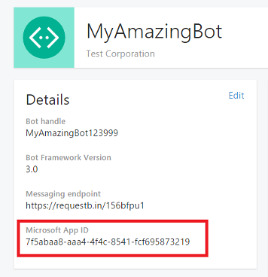

Figure 43: Obtaining the Microsoft App ID for a bot

1. From within Microsoft Teams, on the **Chat** pane, select the **Add chat** icon. For **To:,** paste your bot's Microsoft app ID.

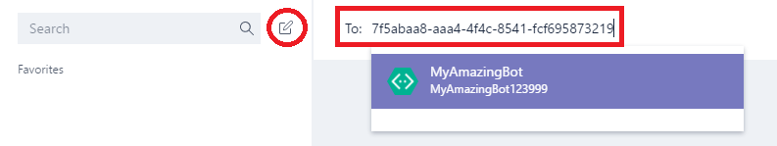

Figure 44: Add custom bot for 1:1 chat

1. The app ID will resolve to your bot name and then you can initiate a chat conversation with that bot

## Security and Compliance

In this section, we will cover how to enable the Security & Compliance features applicable to Microsoft Teams. Before enabling any of these features, ensure you have access to the Security and Compliance Center in the Office 365 Admin Center. By Default, Tenant Admins have access.

Content Search and eDiscovery do not require enablement within the Security and Compliance center. To learn more of how to leverage these services, see the appropriate sections below (Content Search and eDiscovery).

### Auditing and Reporting

The Audit Log provides ad-hoc search capabilities into notable events across Office 365 services. For Microsoft Teams specifically, below are a few examples of events captured:

* Team Creation
* Team Deletion
* Added Channel
* Changed Setting

The complete event list across Office 365 is quite extensive and can be found [here](https://support.office.com/en-us/article/Search-the-audit-log-in-the-Office-365-Security-Compliance-Center-0d4d0f35-390b-4518-800e-0c7ec95e946c?ui=en-US&rs=en-US&ad=US#ID0EABAAA=Audited_activities).

1. Before you can dig into audit insights, auditing must first be enable. To enable Auditing, navigate to the *Security & Compliance* Admin Center. Under *Search for activity*, click on **Start recording now**. After 24hrs, audit data will be available via *Audit Log Search* located under *Search & Investigation* tab.

**Note**: Audit data is only available from the point at which Auditing was enabled.

1. For practical examples of using the Audit Log, see Auditing and Reporting in the Operate section.

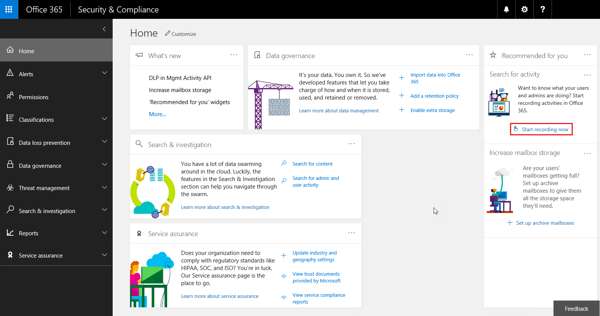

Figure 45: Security and Compliance Home Page

# Operate

## Monitoring Usage and Quality

Microsoft is considering building a set of robust monitoring tools to help you monitor quality and usage of Microsoft Teams. Once these tools are available, guidance will be provided on how customers can leverage these tools to maintain a quality user experience with Microsoft Teams.

## Security and Compliance

This section will outline how to retrieve Microsoft Teams data from the Audit Log, Content Search and eDiscovery.

### Auditing and Reporting

1. To retrieve Audit Log information, navigate to the [Security & Compliance Admin Center](https://protection.office.com/#/unifiedauditlog). Under *Search & Investigation*, select **Audit log search.**

Microsoft Teams has defined audit activities that can be selected as shown below in Figure 46.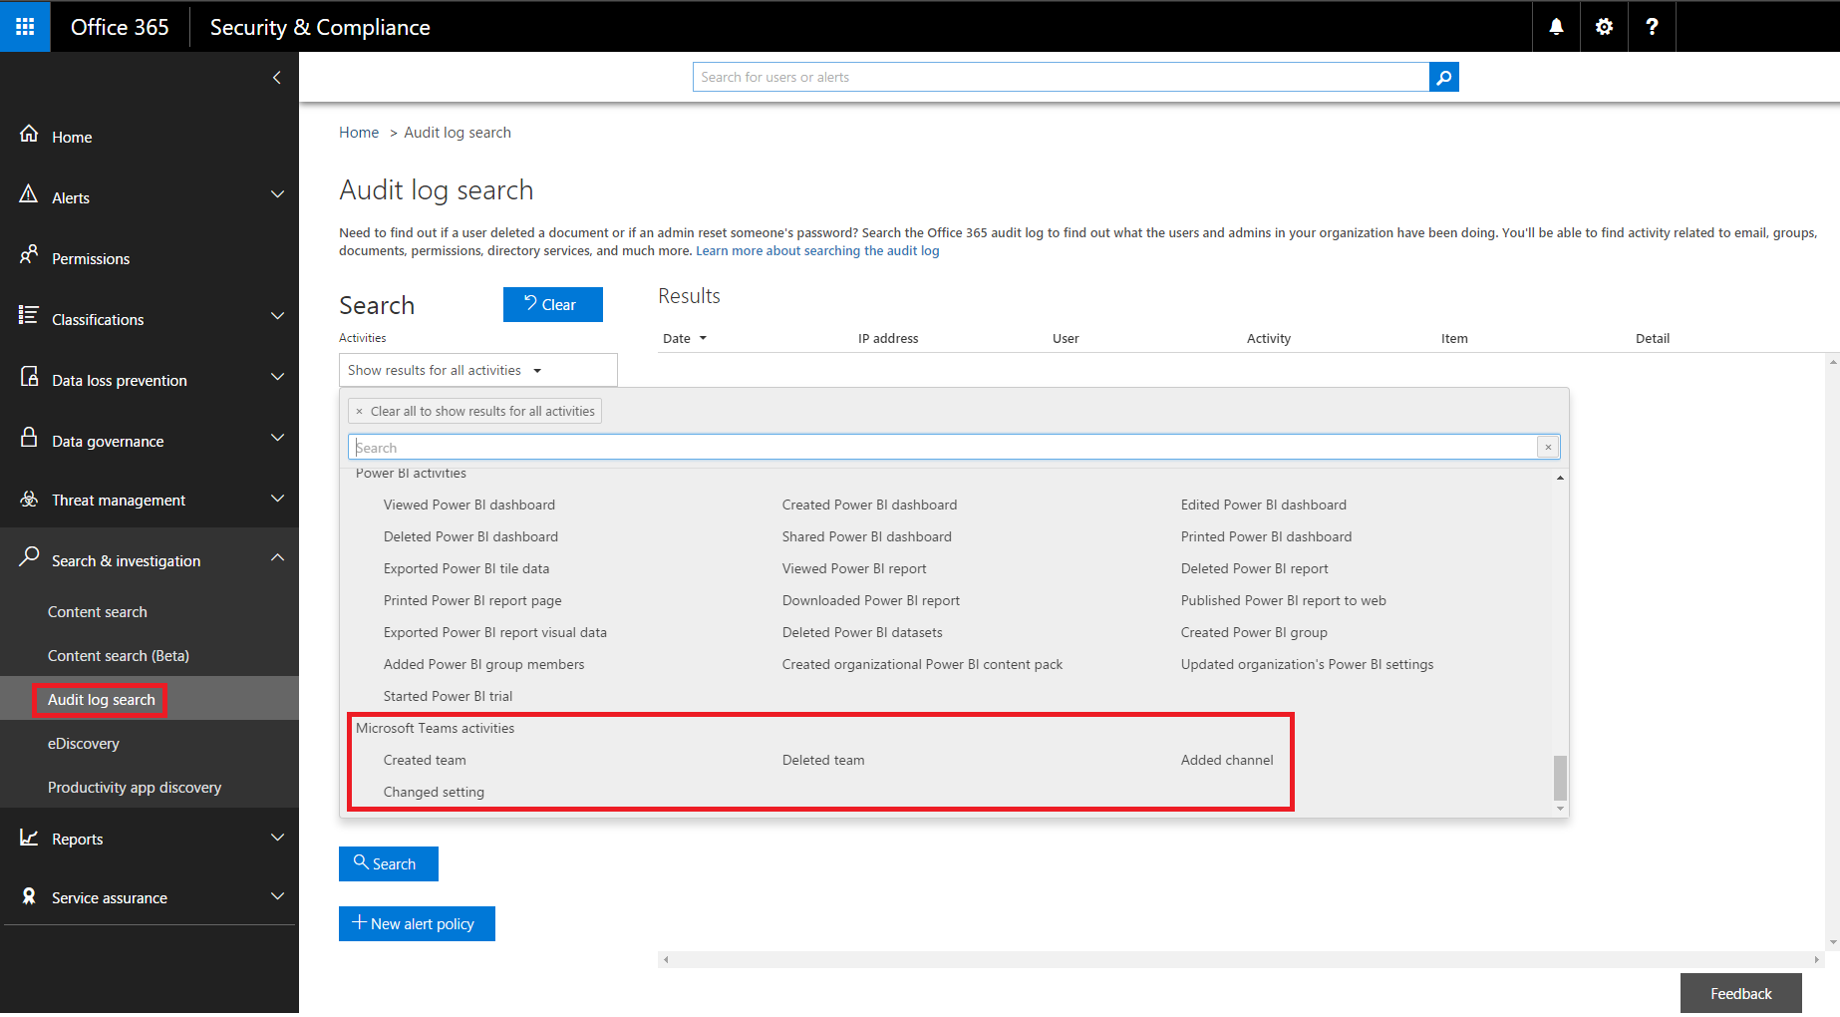

Figure 46: Audit activities

1. After selecting the activities of interest, supply a date range and users to retrieve Microsoft Teams information from. Click **Search** to retrieve the results.
2. This information can be exported to Excel and filtered as needed.

**Note:** if auditing has not been enabled previously, that needs to be enabled before data will appear in the Audit Log.

### eDiscovery

1. To conduct an eDiscovery investigation with Microsoft Teams content, review [this](https://support.office.com/en-us/article/Manage-eDiscovery-cases-in-the-Office-365-Security-Compliance-Center-edea80d6-20a7-40fb-b8c4-5e8c8395f6da?ui=en-US&rs=en-US&ad=US#step1) link.
2. Microsoft Teams data will appear as **IM or Conversations** in the Excel output, or you can mount the **.PST** in Outlook.
   1. When mounting the .PST for the Team, note that all conversations are kept in the Team Chat folder under Conversation History. The title of the message aligns to Team and Channel. From reviewing the image below, you can see this message from Bob who messaged the Project 7 channel of the Manufacturing Specs team.

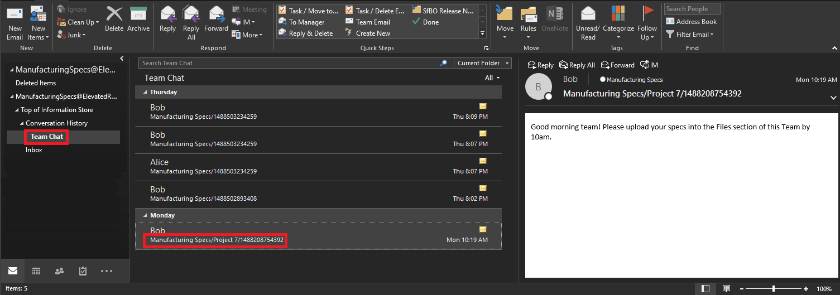

Figure 47: Reviewing Teams conversations using Outlook

1. To see private chats in a user’s Mailbox, they are also located inside the Team Chat folder under Conversation History.

### Content Search

Content Search provides an ad-hoc way to query Microsoft Teams information spanning Exchange, SharePoint and OneDrive for Business.

1. In the example below, we created a new **Content Search**.
2. Then, we selected the Manufacturing Specs mailbox and Manufacturing Specs SharePoint site. This allows us to search against Channel chats from Exchange, File uploads/modifications from SharePoint and OneNote changes as well.

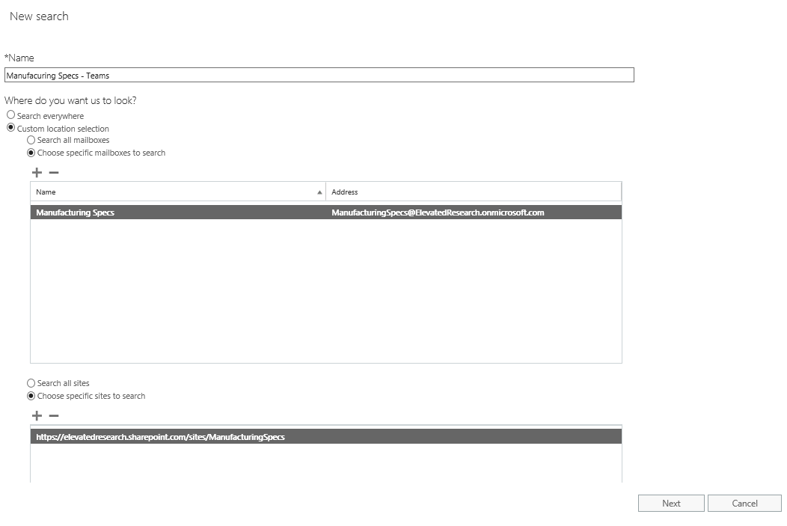

Figure : New Content Search

1. You can also add query criteria to the **Content Search** to narrow down the results returned. For example, below we wanted to search both Exchange and SharePoint locations for the Manufacturing Specs team to look for content where the keywords “**New Factory Specs”** were used.

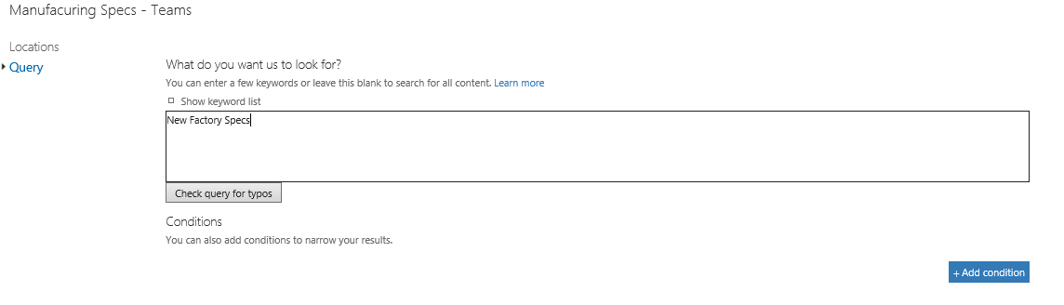

Figure : Add query criteria

1. After adding search conditions should you choose to, you can then export a report or the data to your computer for analysis.
2. For more information on how to use Content Search, review [this](https://support.office.com/en-us/article/Run-a-Content-Search-in-the-Office-365-Security-Compliance-Center-61852fd9-fe8a-4880-a339-cb19ed3bff4a?ui=en-US&rs=en-US&ad=US&fromAR=1) link.

## Troubleshooting

In this section, we will cover troubleshooting service health, connectivity, diagnostic logs and login issues with Microsoft Teams. In the event Microsoft Support is needed, outlining the information commonly asked for to have that ready prior to opening a support case. This section will not cover in-depth log analysis.

### Service Health

Service health for Microsoft Teams is displayed on the Office 365 Admin portal main page. Before troubleshooting issues, it is a good practice to verify that the Teams service is healthy.

Also, keep in mind that, Microsoft Teams is built on top of additional Office 365 services, so when looking at Service Health, remember to also check the status of Exchange, SharePoint and OneDrive for Business. Service Health issues for these other services does not automatically mean that Teams is impacted (e.g. Address Book downloads in Exchange are unavailable), but that you should review the advisories for those affected services to determine if there is an impact to Microsoft Teams.

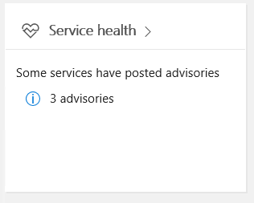

*Figure 50: Service Health*

Figure 51: Service Health dashboard

### Connectivity

Most issues discovered with the Microsoft Teams client can be traced back to firewall or proxy connectivity. Verifying that the necessary URLs, IP addresses and ports are opened in your firewall or proxy will minimize unnecessary troubleshooting. For specific information on URLs and IPs required for Microsoft Teams, please reference the [Office 365 URLs and IP Address](https://support.office.com/en-us/article/Office-365-URLs-and-IP-address-ranges-8548a211-3fe7-47cb-abb1-355ea5aa88a2?ui=en-US&rs=en-US&ad=US#bkmk_teams) support article. The following scenarios require specific URLs and ports to be opened in the firewall.

* Authentication
* Microsoft Teams Client Connectivity
* Collaboration
* Media
* Shared Services
* Third Party Integration
* Skype for Business Interoperability
* Skype for Business Client Interoperability

### Log Files

There are three types of log files automatically produced by the client that can be leveraged to assist in troubleshooting Microsoft Teams.

* Debug logs
* Media logs
* Desktop logs

When creating a support request with Microsoft Support, the support engineer will require the debug logs. Having these logs on hand before creating the support request will allow Microsoft to quickly start troubleshooting the problem. Media or desktop logs are only required if requested by Microsoft.

The following table outlines the various clients, and their associated logs. Log files are stored in locations specific to the client and operating system.

Table - Clients & Logs

|  |  |  |  |
| --- | --- | --- | --- |
| Client | Debug | Desktop | Media |
| Web | X | - | - |
| Windows | X | X | X |
| Mac OSX | X | X | X |
| iOS | - | - | - |
| Android | - | - | - |
| Windows Phone | - | - | - |

For a complete list of supported operating systems and browsers, reference the following [Microsoft Teams FAQ](https://support.office.com/en-US/article/Frequently-asked-questions-about-Microsoft-Teams-%E2%80%93-Admin-Help-05cbe533-2181-4e95-a4b0-52cd7695fafc).

### Debug Logs

These are the most common logs and are required for all Microsoft support cases. Debug logs are produced by the Window and Mac desktop clients, as well as browser based clients. The logs are text based and are read from the bottom up. They can be read using any text based editor and new logs are created when logging into the client.

Debug logs show the following data flows:

* Login
* Connection requests to middle tier services
* Call/conversation

The debug logs are produced using the following OS specific methods:

* Windows:
  1. **Right Click** the Microsoft Teams icon in your application tray, select **Get Logs**
  2. Choosing **Get Logs** from the **Help** pull-down menu
  3. Keyboard shortcut: Ctrl + Alt + Shift + 1
* Mac OSX:
  1. Choosing **Get Logs** from the **Help** pull-down menu
  2. Keyboard shortcut: Option + Command + Shift+1

The debug logs are automatically downloaded to the following folders.

* Windows: %userprofile%\Downloads
* Mac OSX: Downloads
* Browser: You will be prompted to save the debug log to default save location

### Media Logs

Media logs contain diagnostic data about audio, video and screen sharing. They are required for support cases only upon request and can only be inspected by Microsoft. The following table outlines the log location.

|  |  |
| --- | --- |
| Client | Location |
| Windows | %appdata%\Roaming\Microsoft\Teams\media-stack\*.etl |
| Mac OSX | ~/Library/Application Support/Microsoft/Teams/media-stack\*.blog |

### Desktop Logs

Desktop logs, also known as bootstrapper logs, contains log data that occurs between the desktop client and the browser. Like media logs, these logs are only needed if requested by Microsoft. The logs are text based and can be read using any text based editor in a top down format.

|  |  |
| --- | --- |
| Client | Location |
| Windows | %appdata%\Roaming\Microsoft\Teams\logs.txt |
| Mac OSX | ~/Library/Application Support/Microsoft/Teams/logs.txt |

# Appendix

This section of the document contains background information to augment the practical guidance found in the rest of this document organized into Plan, Deliver and Operate sections.

**Note:** This Appendix section is intended for technical audiences such as IT Pros and IT Admins.

## Architecture of Microsoft Teams

Microsoft Teams is built on existing Microsoft technologies woven together by Office 365 Groups.

Out of the box, a team created in Microsoft Teams will create an Office 365 Group with the associated SharePoint Online site complete with SharePoint documents library, an Exchange Online group mailbox for the Group which will be used by Teams to store information—such as meeting invites. A team can be created using existing Office 365 Groups, allowing existing group memberships, and contents stored in SharePoint Online and Exchange Online to be ported to Microsoft Teams.

Microsoft Teams persistent chat capability is provided by a Chat Service that interacts with Office 365 substrate, surfacing many of the built-in Office 365 capabilities such as archiving and eDiscovery to the data being exchanged in Microsoft Teams.

To complement Microsoft Teams capability as a persistent chat board where informal, real-time, conversations around very focused topics or specific sub-groups within the group take place, Teams also provides a meeting’s experience built on the next generation cloud-based infrastructure that is also used by Skype and Skype for Business. These technology investments include Azure-based cloud services for media processing and signaling, H.264 video codec, SILK and Opus audio codec, network resiliency, telemetry, and quality diagnostics.

Office 365 Groups leverage identities stored in Azure Active Directory (Azure AD) and as such, all authentication and authorization capabilities in Azure AD, such as support for multi-factor authentication (MFA), is readily available for use by Microsoft Teams.

To extend Microsoft Teams capabilities, Connectors, Tabs, and Bots are available as extensibility options to bring external information, contents, and intelligent bots interactions to Microsoft Teams.

## Identity and Authentication Methods

Microsoft Teams support all the identity models that are available with Office 365. Supported identity models include:

* *Cloud Identity*: In this model, a user is created and managed in Office 365 and stored in Azure Active Directory, and the password is verified by Azure Active Directory.
* *Synchronized Identity*: In this model, the user identity is managed in an on-premises server, and the accounts and password hashes are synchronized to the cloud. The user enters the same password on-premises as they do in the cloud, and at sign-in the password is verified by Azure Active Directory. This model uses the Microsoft Azure Active Directory Connect Tool.
* *Federated Identity*: This model requires a synchronized identity with the user password is verified by the on-premises identity provider. With this model, the password hash does not need to be synchronized to Azure AD, and Active Directory Federation Services (ADFS) or a third-party identity provider is used to authenticate users against the on-premises Active Directory.

For additional information on Identity and authentication, please see the Identity and Authentication Methods section of this guide.

### Identity and Authentication Configurations

Depending on the decisions around which identity model to implement and use, the implementation requirements may vary. Refer to the requirements table below to ensure that your deployment meets these prerequisites. If you have already deployed Office 365 and have already implemented the identity and authentication method, you may skip these steps.

|  |  |  |
| --- | --- | --- |
| Identity Model | Deployment Checklist | Additional Information |
| All | Compare Office 365 Plan Options and obtain a subscription  Create an Office 365 tenant  Assign Office 365 licenses to the tenant  Configure Domains and admin users  Continue with Identity Model specific instructions | [Office 365 Plan Options](https://technet.microsoft.com/library/office-365-plan-options.aspx)  [Compare Office 365 Business Plans](https://products.office.com/en/business/compare-office-365-for-business-plans)  [Buy licenses for your Office 365 for business subscription](https://support.office.com/article/Buy-licenses-for-your-Office-365-for-business-subscription-36081d8d-b3fa-4948-8c34-e217bba825e1)  [Add licenses to a subscription](https://support.office.com/article/Add-licenses-to-a-subscription-paid-for-using-a-product-key-4fb4bd7e-3920-4ce0-98fb-0c06e3fedf53)  [Set up Office 365 for business](https://support.office.com/Article/set-up-Office-365-for-business-6a3a29a0-e616-4713-99d1-15eda62d04fa)  [Add users and domain with the setup wizard](https://support.office.com/article/Add-users-and-domain-with-the-setup-wizard-6383f56d-3d09-4dcb-9b41-b5f5a5efd611)  Note: If you need assistance, [the Microsoft FastTrack for Office 365 team](http://fasttrack.microsoft.com/office) is available to assist. |
| Cloud Identity | Create users using Office 365 Admin Portal | [Add users individually or in bulk to Office 365](https://support.office.com/article/Add-users-individually-or-in-bulk-to-Office-365-Admin-Help-1970f7d6-03b5-442f-b385-5880b9c256ec) |
| Synchronized Identity | Install Azure AD Connect  Configure Directory Synchronization  Create users using on-premises Active Directory management tools | [Set up directory synchronization for Office 365](https://support.office.com/article/Set-up-directory-synchronization-for-Office-365-1b3b5318-6977-42ed-b5c7-96fa74b08846)  Note: Password hashes must be synchronized for Office 365 to perform authentication. |
| Federated Identity | Install Azure AD Connect  Configure Directory Synchronization  Install and configure a Federated Identity Provider (ADFS recommended)  Create users using on-premises Active Directory management tools | [Set up directory synchronization for Office 365](https://support.office.com/article/Set-up-directory-synchronization-for-Office-365-1b3b5318-6977-42ed-b5c7-96fa74b08846)  [Plan your AD FS deployment](http://technet.microsoft.com/library/dn151324.aspx)  [Checklist: Deploy your federation server farm](https://technet.microsoft.com/library/dn528856.aspx)  [Configure extranet access for AD FS](https://technet.microsoft.com/library/dn528859.aspx)  [Set up a trust between AD FS and Azure AD](https://technet.microsoft.com/library/jj205461.aspx)  [Verify and manage single sign-on with ADFS](https://technet.microsoft.com/library/jj151809.aspx)  [Azure AD federation compatibility list](https://docs.microsoft.com/azure/active-directory/connect/active-directory-aadconnect-federation-compatibility)  Note: Password hashes do not need to be synchronized to Azure Active Directory. |

Refer to [Choosing a sign-in model for Office 365](https://blogs.office.com/2014/05/13/choosing-a-sign-in-model-for-office-365) and [Understanding Office 365 identity and Azure Active Directory](https://support.office.com/article/Understanding-Office-365-identity-and-Azure-Active-Directory-06a189e7-5ec6-4af2-94bf-a22ea225a7a9) guides for additional details.

### Multi Factor Authentication

Office 365 plans support Multi-Factor Authentication (MFA) that increases the security of user logins to Office 365 services. With MFA for Office 365, users are required to acknowledge a phone call, text message, or an app notification on their smartphone after correctly entering their password. Only after this second authentication factor has been satisfied, can a user sign in.

Multi Factor authentication is supported with any Office 365 plan that that includes Microsoft Teams. The Office 365 subscription plans that include Microsoft Teams are discussed later in the Licensing section below.

Once the users are enrolled for MFA, the next time a user signs in, they see a message that asks them to set up their second authentication factor. Supported authentication methods are:

Table 14 – Multi Factor Authentication Support

|  |  |  |
| --- | --- | --- |
| Tenant Type | Available MFA Second Factor options | Notes |
| Cloud Only | MFA for Office 365   * Phone Call * Text Message * Mobile App Notification * Mobile App Verification Code | [Plan for multi-factor authentication for Office 365 Deployments](https://support.office.com/article/Plan-for-multi-factor-authentication-for-Office-365-Deployments-043807b2-21db-4d5c-b430-c8a6dee0e6ba) |
| Hybrid setup  (Synchronized or Federated Identity model) | * MFA for Office 365 * Azure MFA module (ADFS integrated) * Physical or virtual smart card (ADFS integrated) | Note: Additional MFA solutions are available with [Identity providers that are compatible with Azure AD federation](http://go.microsoft.com/fwlink/p/?LinkId=510953). |

**Note:** The table above represents the MFA support for Microsoft Teams. Not all Office 365 workloads might support all the options in presented in the table. Just an example: Skype for Business does not support MFA when configured in hybrid mode. Make sure that you follow the [guide](https://support.office.com/article/Plan-for-multi-factor-authentication-for-Office-365-Deployments-043807b2-21db-4d5c-b430-c8a6dee0e6ba) for application specific MFA support.

## Exchange Deep Dive

Generally, you should not have to configure any Exchange Online functionality for use with Microsoft Teams. However, for Exchange Hybrid scenarios, there are steps necessary to ensure Group conversations in Outlook/OWA flow between Exchange Server (on-premises) and Exchange Online. This involves enablement of Group Writeback functionality in Azure AD Connect along with various initialization scripts. If you do not follow the steps in this article, your on-premises Exchange Server people won’t be able to respond to Groups conversations using Outlook/OWA where the SMTP alias for the Group is in the “To” or “Cc/Bcc” line: [Configure Office 365 Groups with on-premises Exchange hybrid](https://technet.microsoft.com/en-us/library/mt668829(v=exchg.150).aspx)

**NOTE**: Deleting an Office 365 Group will remove the mailbox alias for persistent conversations and mark the SharePoint site for deletion. It takes approximately 20 minutes between the removal of a Team and its effect on Outlook. Deleting a Team from the Teams client will remove it immediately from view to all who are members of the team. If you remove a member of an Office 365 Group which has had Teams functionality enabled on it, there could be a delay of approximately one hour before the Team is removed from view in the Teams client for the effected people who were removed.

### How does Exchange hosting change what users can do in Teams?

For the full Microsoft Teams experience, every user should be enabled for Exchange Online and SharePoint Online.

Users' Exchange mailboxes can be hosted online or on-premises; however:

* Users with Exchange mailboxes on-premises cannot configure connectors, but can still receive messages from connectors configured by other users.
* Users hosted on Exchange Online Dedicated Legacy or on-premises cannot create or view meetings, modify their user profile picture, or configure connectors.

The following table gives more specific information, for users with Exchange hosted in other environments.

***Note:*** *For the latest information on this, please see the online* [FAQ](https://support.office.com/en-US/article/Frequently-asked-questions-about-Microsoft-Teams-%25E2%2580%2593-Admin-Help-05cbe533-2181-4e95-a4b0-52cd7695fafc?ui=en-US&rs=en-US&ad=US)*.*

|  |  |  |  |  |  |  |  |  |
| --- | --- | --- | --- | --- | --- | --- | --- | --- |
|  | Actions supported: | | | | | | | |
| User's mailbox is hosted in: | Create teams | Join teams | Create channels | Create and view meetings | Modify user profile picture | Add and configure connectors | Add and configure tabs | Add and configure bots |
| Exchange Online | Yes | Yes | Yes | Yes | Yes | Yes | Yes | Yes |
| Exchange Online Dedicated vNext | Yes | Yes | Yes | Yes | Yes | Yes | Yes | Yes |
| Exchange Online Dedicated – Legacy (Sync to Azure AD required) | Yes | Yes | Yes | No | No | No | Yes | Yes |
| Exchange on-premises (Sync to Azure AD required) | Yes | Yes | Yes | No | No | No | Yes | Yes |

Users with Exchange mailboxes hosted on-premises or on Exchange Online Dedicated Legacy can use all features of Microsoft Teams except the following:

* Create or view meetings
* Modify their user profile picture
* Configure connectors

### Notification by email of membership to Groups

Whether you create an Office 365 Group in the admin console or by using Outlook, Exchange Online is used to send notifications of a team member being added to a Group. These messages are generated from your tenant as they represent your default domain SMTP FQDN.

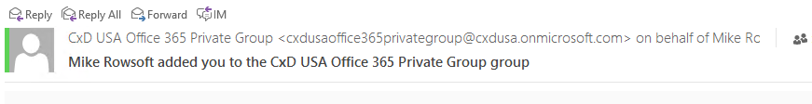

Teams uses Microsoft Exchange Online as well to send notifications to team members when they’ve been added. The difference being the domain FQDN of the SMTP message is “@email.teams.microsoft.com” and could be caught by spam filtering. As you can see from the image below, Outlook considers this message as an external sender which is subject to standard security features such as blocking images and certain content.

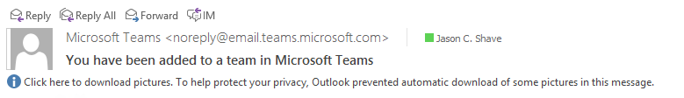

Consider adding the Microsoft Teams SMTP domain to your “accepted domains” list in your Exchange Online spam configuration:

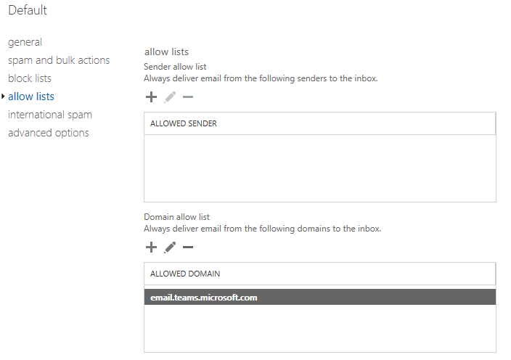

## Office 365 Groups

Microsoft’s Office 365 Groups feature incorporates a multitude of features pulled together from various existing cloud workloads. For example, at the basic level, an Office 365 Group consists of a security object defined to associate a user’s account identity along with a SharePoint document library, Yammer Group, and shared Exchange mailbox resources. You can add or remove people to the Group just as you would any other group-based security object in Active Directory.

An Office 365 administrator can define an Office 365 Group, add members, and benefit from features such as an Exchange shared mailbox, SharePoint document library, Yammer Group, etc. For more information about Groups visit: [Learn about Office 365 Groups](https://support.office.com/en-us/article/Learn-about-Office-365-groups-b565caa1-5c40-40ef-9915-60fdb2d97fa2).

### Why are Office 365 Groups important?

Groups in Office 365 anchor the user experience across platforms such as Exchange Online, SharePoint Online, Yammer, and now Teams. When you create a new Team, an Office 365 Group is automatically created with the members you choose when setting it up. This means your Team can collaborate using experiences driven from the web, all the way through to rich applications like the Teams client.

When you create a Team, you’re creating an Office 365 Group along with the associated SharePoint document library, OneNote notebook, along with ties into other Office 365 cloud applications. If the person creating the Team is an owner of an existing Office 365 Public or Private Group, they can add Teams functionality to the Group. This creates one default “General” channel in which chat messages, documents, OneNote, and other objects reside. Viewing the document library for the channel will reveal the “General” folder representing the channel in the Team. More importantly, , if you create your own folder structure within a document library **it does not propagate** to Teams as a channel; for now, it only flows from Teams into SharePoint.

### Group Membership

Depending on where you drive group membership from, depends on what features and capabilities your users will experience. For example, if you remove a member of a Team, they are removed from the Office 365 Group as well. Removal from the Group immediately removes the Team and channels from the Teams client. If you remove a person from a Group using the Office 365 Admin portal, they will no longer have access to the other collaborative aspects such as SharePoint Online document library, Yammer Group, or shared OneNote. However, they will still have access to the Team’s chat functionality for approximately one hour.

Our guidance with respect to Teams ‘member management’ is to drive the add/remove functionality through the Teams client to ensure the correct cascading access control to other dependent cloud applications is applied. Additionally, you will avoid a disjointed experience leaving people with the impression they still have access to the resources they used to (until the next sync cycle either adds or revokes access to a particular component of the service).

### Planning considerations for Office 365 Groups

When considering the use of Office 365 Groups or when creating teams, consider what the team will be used for, who should have access, and what outcome the team will expect to achieve. Pay special attention to the number of channels you create as people can quickly become overrun by content spread too thin (across too many channels).

There are two scenarios that warrant some discussion around planning of Office 365 Groups and their impact on (or by) Teams:

* First, since customers could have existing investments in Groups, we currently support both Public and Private groups of less than 999 members. As mentioned previously, you want to manage the membership of people to a Team using the Teams client rather than the Office 365 admin web console. Given this scenario, if people are used to threaded conversations in Office 365 Groups, it is worthwhile noting that a Groups conversation is essentially email and not the same as a chat message in a Team channel. Educate your people about this difference and suggest they adopt the more flexible chat message format in Teams versus emailing the Group using Outlook or OWA.
* Second, for customers who don’t have existing Groups defined in Office 365, you can either create them using the Office 365 admin portal, the Teams web, or desktop clients. As mentioned previously, manage all future membership to the Office 365 Group using the Teams client. Since membership to a Team is also defining membership to Office 365 Groups, you should prepare people for this change.

The following articles are a good place to find readiness & adoption content for your Office 365 Groups:

* [Get more with groups in Outlook](https://support.office.com/en-us/article/Get-more-with-Office-365-Groups-in-Outlook-93132800-5b11-49de-8cc2-605b6075b2b9)
* [Manage Group membership in the Office 365 admin center](https://support.office.com/en-us/article/Manage-Group-membership-in-the-Office-365-admin-center-e186d224-a324-4afa-8300-0e4fc0c3000a)

## SharePoint Online and OneDrive for Business

Each team in Microsoft Teams has a team site in SharePoint Online, and each channel in a team gets a folder on this SharePoint Online site. Files shared within a conversation are automatically added to the documents library, and permissions and file security options set in SharePoint are automatically reflected within Teams.

Private chat files are stored in the **sender’s** OneDrive for Business folder, and permissions are automatically granted to all participants as part of the file sharing process.

If you don't have SharePoint Online enabled in your tenant, Microsoft Teams’ users cannot always share files in teams. Users in private chat also cannot share files because OneDrive for Business (which is tied to the SharePoint license) is required for that functionality.

By storing the files in the SharePoint Online document library and OneDrive for Business, all compliance rules configured at the tenant level will be followed.

The following are the example of relationships between team, channel, document library, and OneNote notebook.

For every team, a SharePoint site is created, and the *Shared Documents* folder is the default folder created for the team. Each channel, including the **General** channel, the default channel for each team, has a folder under the *Shared Documents* folder.

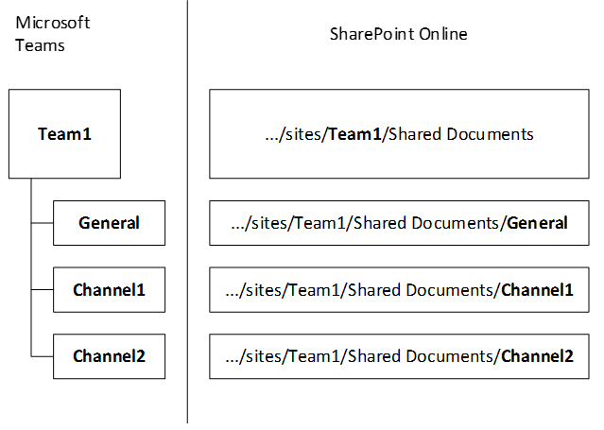

For every user, the OneDrive folder *Microsoft Teams Chat Files* is used to store all files shared within private chats with other users (1:1 or 1:many), with permissions configured automatically to restrict access to the intended user only.

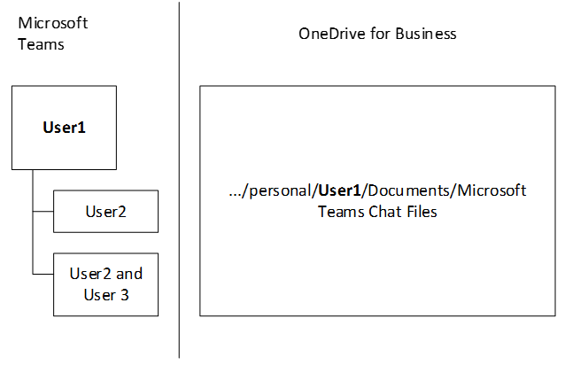

## Microsoft Teams Feature-level Enablement

This section describes each of the different IT admins options that are available.

### General Settings

The General section lets you configure the following settings for your organization:

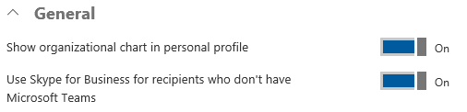

* **Show organizational chart in personal profile:** As the text implies, if this setting is enabled, organizational chart button will be shown in the users contact card and when clicked, the detailed organizational chart will be displayed.

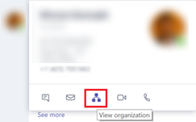

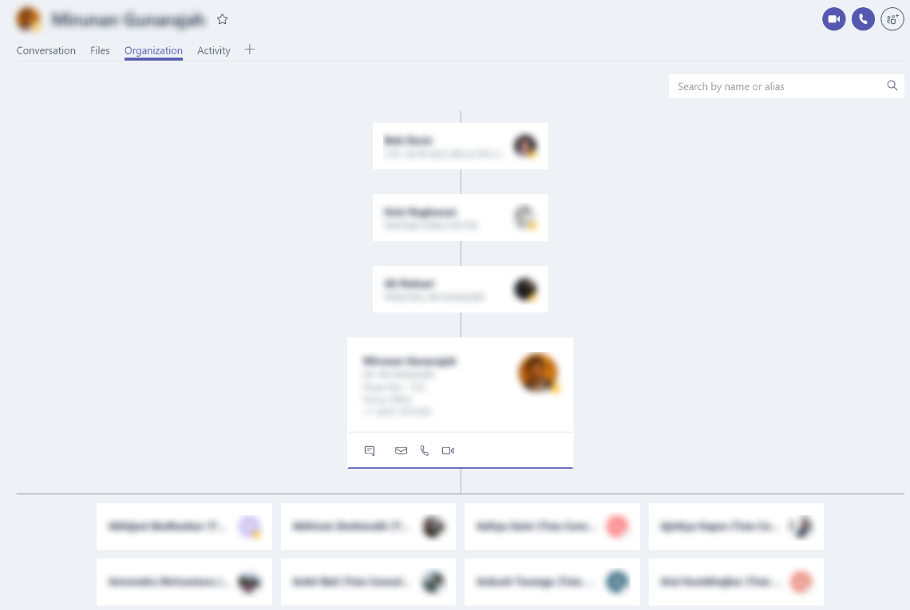

* **Use Skype for Business for recipients who don’t have Teams:** Setting allows Teams users to send IM to Skype for Business users who have never signed into Teams and allow them to get an email notification in the Outlook mailbox.

### Calls and Meetings

The Calls & Meetings section lets you configure the following settings for your organization:

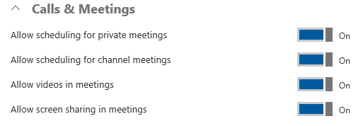

* **Allow scheduling for private meetings:** When enabled, users can schedule private meetings that would not be listed in any channel.
* **Allow scheduling for channel meetings:** When enabled, users can schedule a meeting for a channel that all channel members can easily join with a single click.
* **Allow videos in meetings:** Specifies whether the use of video is allowed within the meetings.
* **Allow screen sharing in meetings:** Specifies whether the screen sharing is allowed within the meetings.

### Messaging Settings

The Messaging section lets you configure the following settings for your organization:

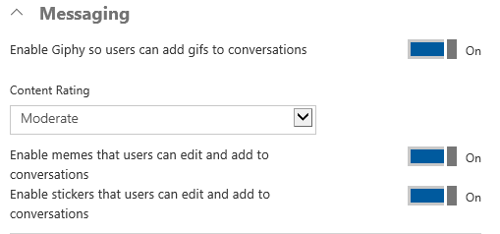

* **Enable Giphy so users can add gifs to conversations:** When enabled, users can use animated pictures within the conversations.
  + **Content Rating:** When animated images are turned on, content rating can be applied to restrict the type of animated images that can be displayed in conversations. Available content rating options are:
    - No restriction
    - Moderate
    - Strict
* **Enable memes that users can edit and add to conversations:** When enabled, users can use internet memes to make post humorous.
* **Enable stickers that users can edit and add to conversations:** When enabled, users can post images with editable text to call channel members attention.

### Bots & Tabs Settings

Tabs in Microsoft Teams are a terrific way to integrate the tools and services your team cares about, right into any channel or chat whereas bots allow your users to interact with your service through Microsoft Teams chat conversations.

The Tabs and bots section lets you configure the following settings for your organization:

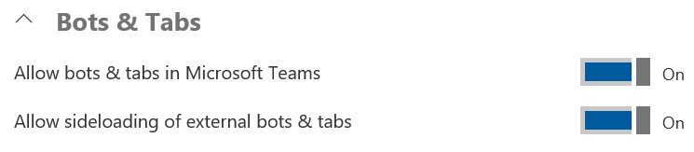

* **Enable bots & tabs in Microsoft Teams:** When enabled, both the bots and tabs functionality throughout the Office 365 tenant will be enabled. With that, tabs can be added to all channels and chats by the users and the default T-Bot, an embedded assistant that would help your users learn how to use Microsoft Teams, will be activated.
* **Allow side loading of external bots & tabs:** When enabled, users can install and enable custom bots and tabs.

### Email Integration

The Email Integration section lets you configure the following settings for your organization:

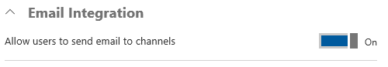

* **Allow email integration into channels:** When enabled, mail hooks are enabled, and users can post messages to a channel by sending an email to the email addresses of the Microsoft Teams channels.